STRATEGIES TO INCLUDE ‘MULTIPLY MARGINALISED’ GROUPS IN ELECTIONS

The inclusion of Youths, women, and persons with disabilities in the electoral process, is actually raising awareness and is increasingly gaining grounds in Cameroon.
With the recent population census in Cameroon, many persons with disabilities who have attained the age of voting, were found to constitute a great majority of the population. With a view to give effect to these ideas and make the most of on the recent population census, a lot have been put in place, both by the Government and the lone Election Management Body, Elections Cameroon (ELECAM).
The Government on its part passed as (Law No. 2O10 of 13 April 2010), which relates to the Protection and Welfare of Persons with Disabilities in Cameroon. Its Section 2: defines disability as “limitation of a person’s ability, due to a deficiency, to fully participate in an activity in a given environment”. The same law defines the person with a disability as, “any person who is unable to fulfil by themselves all or part of the requirements of a normal personal or social life, as a result of a physical or mental disability, be it of birth or otherwise”.
In respect of these realities and given the need to ensure the social and political integration of persons with disabilities, under Section 27 (2) of this law, specifies that, “the State shall encourage the presence of persons with disabilities in various bodies of social and political integration of persons with disabilities”.
Elections Cameroon, (ELECAM) on its part, have been facilitating and ensuring an effective consideration of persons with disabilities and gender throughout its electoral processes.
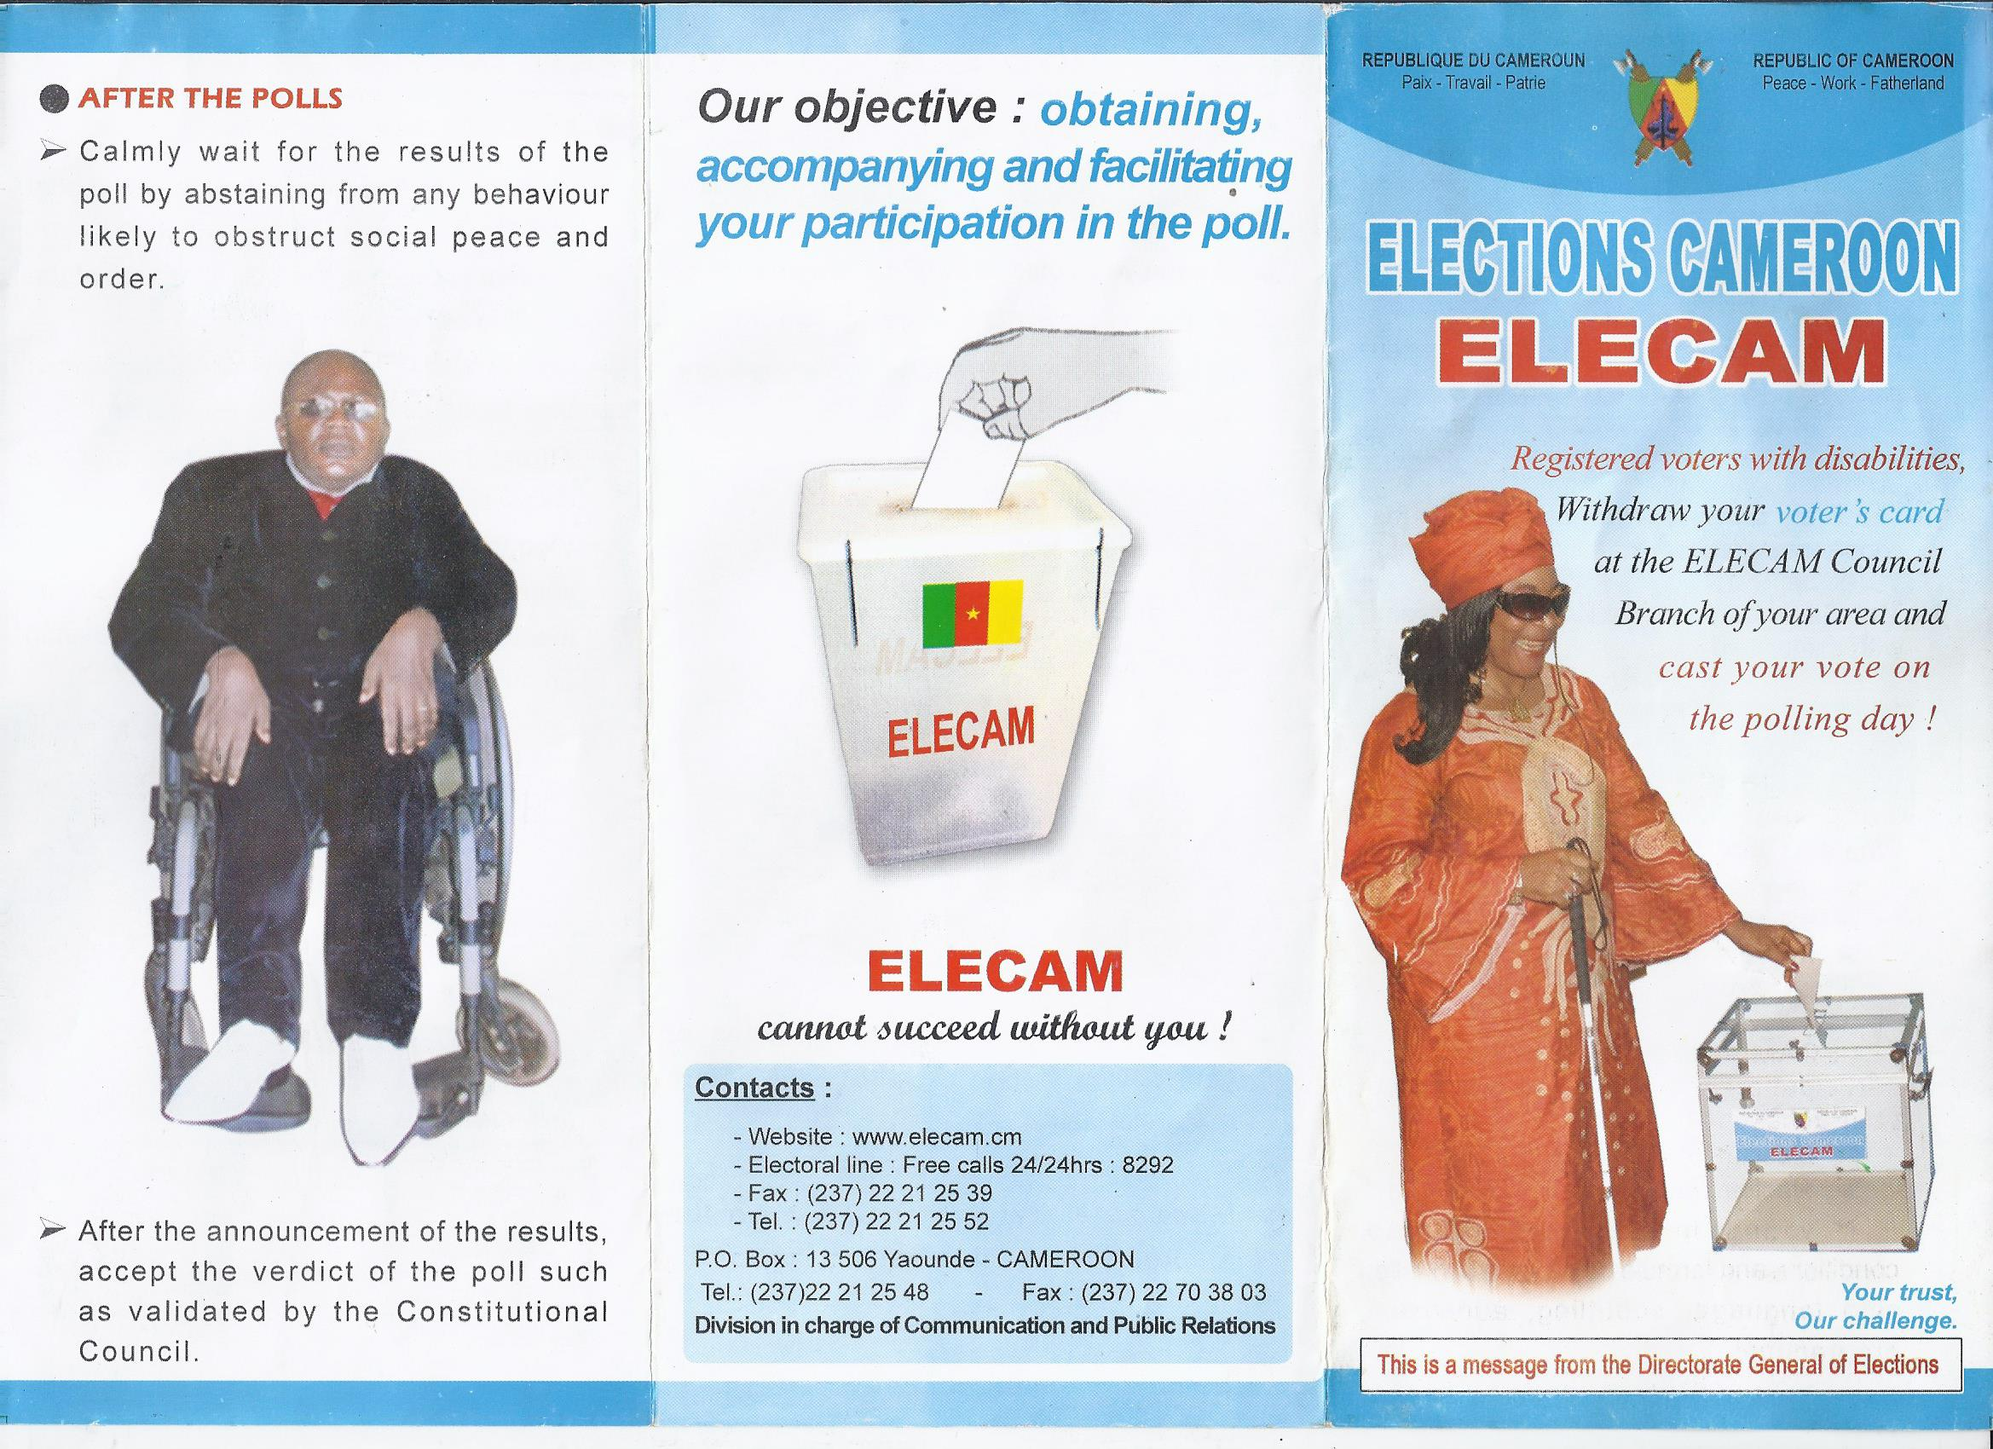
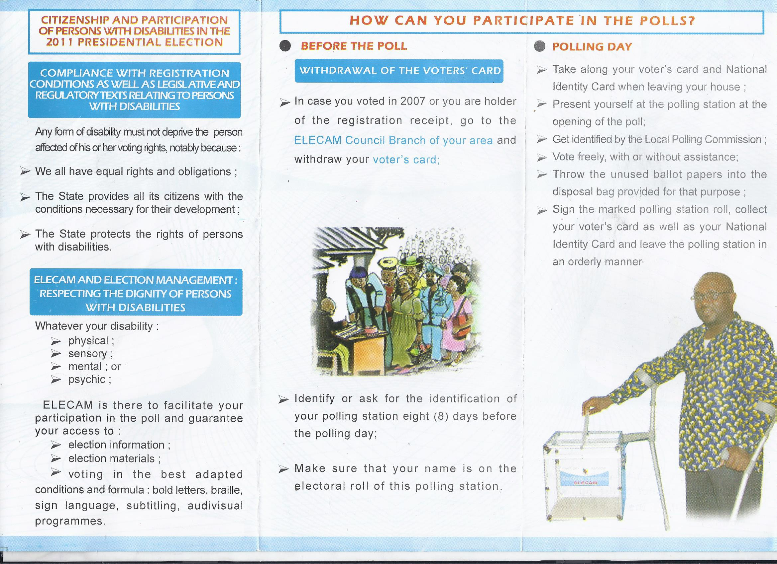

(Flyer curtsy: Division in charge of Communication and Public Relations, Elections Cameroon (ELECAM)

Opportunities and Constraints
To curtail the disparity between men and women in the domain of elections, we could rely on certain measures existing at the political, economic or social levels.
The affirmation of gender equality in legal instruments constitutes a trump card in the implementation of the Strategic plan for Gender and Elections in Cameroon.
The participation of every female and male citizen in the government of his/her country through free elections is entrenched, taking into account parity, at the international, regional and national level.
At the international level:
- the ratification by Cameroon of regional and international conventions and agreements relating to advocacy for women’s rights. All these international instruments affirm the 12 principle of equality and prohibits any form of discrimination based notably on gender;
- the Universal Declaration of Human Rights of 1948;
- the International Covenant on Social and Cultural Rights of 1966;
- the UN Convention on the Elimination of All Forms of Discriminations Against Women of 1984.
To these instruments, one could add:
• the Beijing 1995 Platform for Action and its subsequent action plans or the 2000 Millennium Declaration that advocates for gender equality.
At the regional level, one could, among others, add:
• the Constitutive Act of the African Union;
• the African Charter on Human and People’s Rights of 1981;
• the Addis Ababa Declaration of Heads of State and Government on Gender Equality in Africa of 2004;
• the African Charter on Elections, Governance and Democracy of 2007. At the national level, one could cite:
• the participation of Cameroon in international forums on advocacy for gender approach in all domains like the Beijing Declaration;
• the creation of a Ministry of Women’s Emancipation and the Family;
• the adoption as from 1990 of laws relating to freedom in public life that favoured the creation of a multitude of women’s rights associations;
• the formal introduction of the gender concept in the Electoral Code of 2012;
• the political determination of Government shown through initiatives like the elaboration of the Poverty Reduction Strategy Paper, whose sector strategies lay particular emphasis on the development of women notably by improving her socio-legal status, her living conditions and on gender equality and equity in all sectors of national life;
• the Assertion of Political Will towards integrating gender approach in all domains with focus on the advancement of women in government policymaking;
• the Sensitisation, Communication and Civic Education of the electorate with specific measures centred on women, backed by partners of development.
Despite the existence of such encouraging measures, there are still numerous constraints among which are:
- the absence of a specific law on parity or quotas;
- the poor information of women;
- the inadequate training of women, who are often under-educated, which generally limits their access to the political process;
- the burden of tradition and culture
- the reticence of political parties for the endorsement of female candidacies;
- the inexistence of an independent national body responsible for gender equality.
In the same vein, the following specific objectives could be drawn from this main objective:
- identifying constraints on equal participation for women in the electoral process;
- proposing a series of corrective measures to create enabling conditions for the participation of women and men in the electoral process;
- preparing a gender approach operational plan relating to elections such as to incite a greater involvement of both female and male citizens in the electoral process;

5)-Strategies Proposed by the Plan
The activities earmarked are multifarious and wide-ranging. They focus on all phases of the electoral process. They must, above all, be carried out by all stakeholders of the process for greater effectiveness.
In view of the implementation of this strategic plan, the following strategies have been proposed:
- reform of the legal framework that shall mainly involve an effective consideration of new provisions aimed at facilitating gender integration in elections;
- elaboration and adoption of a provision aiming for parity or a quota of at least 30%;
- capacity building of stakeholders (Political Parties, Civil Society Organisations, the Media, ELECAM staff) and institutions through specific trainings;
- capacity building of women aspiring for electoral mandates and elective positions in leadership;
- conception and production didactic media;
- assistance in upgrading the electoral roll, production of election documents and distribution of voter cards;
- mobilisation, sensitization and civic education of stakeholders of the electoral process.
(Curtsy: PRESENTATION OF THE STRATEGIC PLAN FOR GENDER AND ELECTIONS IN CAMEROON YAOUNDE, MONT FEBE HOTELMONDAY, 11 JUNE 2012: http://www.elecam.cm/uploads/media/Strategic_Plan_for_Gender_and_Elections.pdf )
Yaounde, 19th November, 2014
By Susana Dione Ngole Epie
Senior Staff, Unit for Legal Affairs
Elections Cameroon (ELECAM)
secharles11@gmail.com sepiepang@yahoo.com

