IFES Report
IFES-NAPEN Election Violence and Peace Monitoring

www.nevr.org
Election Violence and Peace Making Platform for IFES, NAPEN

TABLE OF CONTENTS
Page

1. Introduction……………………………………………..……….…………3
1.1 Preamble………… …………………………………………… ………….3
1.2 Objective…… ………………………………………………….……….....3
  - Project Scope…… ………………………………………………………...3
  - Project Scope Extension…………………………………………………...3

2. Project Details………………………………………………………………4
2.1. The Ushahidi Open-source Application … ………………………………4
2.2. The SMS Transmission Set-up……………………………………………4
2.3. Hosting ………………………………………………………………..….4
2.4 Access and Passwords…………………………………………………..…5

3 Challenges
3.1. How some of the Challenges were Overcome…………………………6
3.1.1. SMS Transmission…………………………………………………..…6
3.1.2. Functionality Modification…………………………………………....6
3.1.3. Ushahidi Bugs…………………………………………………………6
3.1.4. Wrong Message Formatting…………………………………………...7

4.0. Resource Management …..……………………………………………..7
4.1 Statistics of total SMS traffic onlongcodes …………………………...7
4.2 Lessons Learnt ………………………………………………………….9

5.1. Recommendations……………………………………………………….9

- Introduction

  - Preamble

WANGONeT was contacted in November 2010 with the prospect of helping to develop a platform for monitoring the possible electoral violence and the events aimed at fostering peace in the April 2011 elections.

The project (an internet-based portal) was conceptualized by IFES and designed by WANGONeT to assist NAPEN in analyzing, monitoring, and advocating against election violence by making it easier and more convenient to track and report outbreaks of violence before, during, and after the elections.
The project officially took off on the first week of December with analysis and test deployment of the recommended open source tool (Ushahidi) which was capable of achieving the functionality described in the proposal received by WANGONeT.
The Ushahidi deployment was successful even though the tool’s functionality was extended to meet the requirements of IFES.

  - Objective

To remotely report incidences of violence or peacemaking during the 2011 Nigerian Elections
  - Project Scope

The initial project scope was documented on Page 6 of the Request for Proposal, under section 4.1 (Scope of Work), and it was to deliver a highly secure internet portal that allowed for an SMS relay system, backend data management, frontend incident mapping, compelling interfaces and a public website for hosting other information, project files and multimedia hosting. The initial project timeline was 4 weeks i.e. the end of the December.

  - Project Scope Extension
As is to be expected in the deployment of an open source code, there would be a need for increased customization of the application. This was experienced during the deployment of the www.nevr.org. This extended the deployment duration by close to 4weeks, extending way into January. Quite a lot of customization-related requirements were not brought to WANGONeT’s notice either in the Request for Proposal or within the agreed development timeframe. This not only strained WANGONeT’s human-resources but also affected the timelines for delivery because some built-in functionality were modified during the development process which implied lots of testing to ensure that other dependent or co-dependent functionality were not broken. Even though much of the work done during this extension was not covered by the initial contract, WANGONeT bore the cost in good faith.

2.Project Details

2.1.The Ushahidi Open-source Application
The Ushahidi platform is built on the Kohana web framework, a fork of the CodeIgniter framework. It includes built-in support for Nexmo wholesale SMS API, FrontlineSMS, Clickatell SMS gateways, etc. Ushahidi provides the option of using OpenStreetMap, Yahoo maps, Bing Maps, and Google Maps in its user interface. Ushahidi is often set up using a local SMS gateway created by a FrontlineSMS set-up.

2.2.The SMS Transmission Set-up
The SMS transmission/relay system was setup using two longcodes (provided by MTN and VISAFONE) for inbound messages and a BulkSMS provider (nuObjects) for outbound messages. Ushahidi was configured with the appropriate HTTP APIs to create a seamless integration between the three systems. The usage of the systems was transparent and intuitive as access to these APIs were implemented through the web interface. WANGONeT customized the Ushahidi to create a Gmail kind of threaded conversations between POs and Monitors using the SMS relay.

2.3.Hosting
The www.nevr.org website was hosted on Joyent servers. Joyent is a global cloud computing software and services company offering cloud computing solutions worldwide since 2004. Joyent licenses its cloud software, SmartDataCenter, to service providers, like Dell, who deliver cloud services to their own customers. In addition, Joyent runs an instance of SmartDataCenter for some of the most innovative companies in the world, such as LinkedIn, Gilt Groupe and Kabam.

2.4.Access and Passwords
Description | URL | User | Password
Webmin/Virtualmin Interface | https://nevr.org:10000/ | nevr | nlQFGXZUWVclbBu
SFTP File Management (FULL) | sftp://nevr.org | nevr | nlQFGXZUWVclbBu
SFTP File Management (Partial, File Uploads) | sftp://nevr.org | upload | oukeh.napen
Website Administration | http://nevr.org/admin | Usernames and Passwords remain as they are for everyone who had access to the system originally.

3.Challenges
Some challenges were faced in the course of the Project. The more daunting challenge was the telecom setup for SMS transmission. Although there were more than a couple of choices to choose from, they all had low levels of reliability. The major problem was the fact that any telecom-dependent project would have to inherit all the reliability issues common to the telecom companies in Nigeria.

The second challenge was that requests for functionality modifications were being made on the fly which considerably elongated the timelines because of the need for extensive testing.

The third challenge was the existence of many bugs in the Ushahidi code base. Although this is not unexpected in an open-source installation, but the more modifications WANGONeT had to make, the more dependency errors were created thus creating an almost system wide tweaking of the code base.

The fourth challenge was a lack of adequate testing. For an open-source code based project, it is always advisable to have a focused group testing before scaling. This meant that much of the learning and tweaking had to be done as it happened. This led to an increased number of downtimes during the course of the project.

The fifth challenge was the Joyent server crash on the 24th of March, 2011. Unfortunately, the backups available were too old to be of any significant use. We had to work around the clock to restore data from the available backups and the messages logged at the incoming and outgoing sms gateway. This subsequently led to some down time but we were able to get the site back up in 3 days but not without some data loss. After the experience, we ensured our backup service was updated.

Other challenges included the user interface and user interaction setup. The system had to be setup to accommodate even the most inexperienced user, and even when the monitors sent messages in incorrect formats, WANGONeT had to modify the system, to be intelligent enough, to infer the meaning of such messages. All these had to be accommodated into the algorithm that processed the inbound messages.

3.1.How some of the Challenges were Overcome

3.1.1. SMS Transmission
The challenge with the telecom setup was overcome by deploying a hosted-sim solution, which guaranteed lower costs, both to IFES and NAPEN, and a relatively fairer reliability level. Most of the issues with telecoms, post-development time, were sorted out through quick response to feedback from the field as most of these issues were found out by the monitors on the field and also the program officers.

3.1.3.Functionality Modification
WANGONeT had to deploy more resources to deliver the requested functionality thus affecting organizational production capacity. This was most evident in January. Also, WANGONeT had to ensure that extensive testing of functionality and the potential adverse effects of runtime modifications were carried out. Some bugs escaped the test beds but they were fixed, promptly, as feedback came from the field.

3.1.4.Ushahidi Bugs
Since WANGONeT took responsibility for the Ushahidi code (open-source software do not usually come with support) in this particularly deployment, WANGONeT we had to ensure that bugs were fixed. WANGONeT also reported its findings to the Ushahidi team in the hopes that the recommendations would be worked into subsequent versions.

3.1.5. Wrong Message Formatting
Some monitors were called up and corrected on how to properly format messages sent into the system.

4 .Resource Management
4.1. Statistics of total SMS traffic on long-codes
LongCode | Incoming | Outgoing
07026702053 | 194 | 342
08166552827 | 353 | 616
Total | 547 | 958

Month | Incoming | Outgoing
January | 6 | 55
February | 50 | 57
March | 172 | 262
April | 301 | 493
May | 17 | 82
June | 1 | 4
July | 0 | 4
August | 0 | 1
Total | 547 | 958

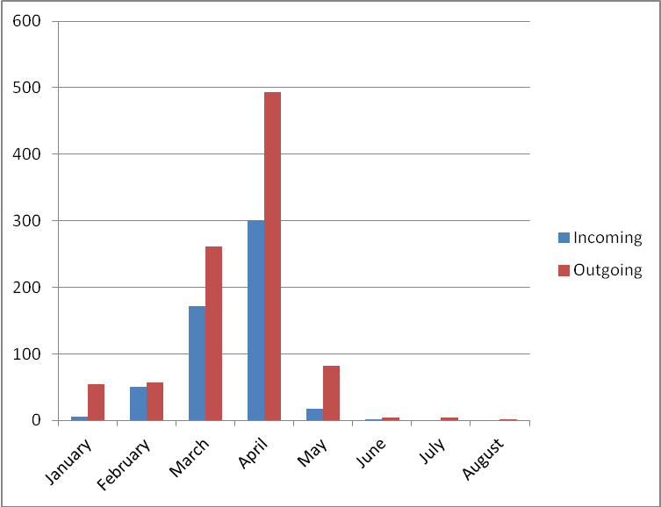

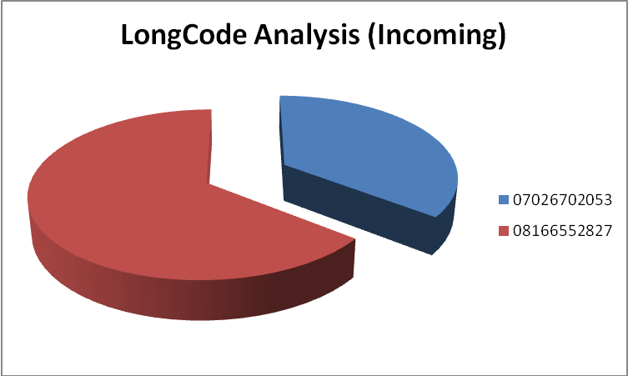

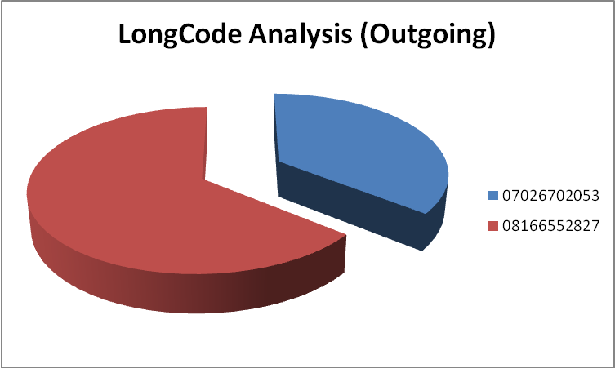
4.2. Lessons Learnt
- Systems have to be designed to accommodate even the most inexperienced of users.
- User feedback is very important and necessary in deployment of systems, particularly open-source systems.
- Adequate testing must be done for systems that rely heavily on third-party systems i.e. telecoms.

5.1. Recommendations
It is recommended that time for adequate testing, before going live, be incorporated into subsequent project plans, to ensure that most loose ends are tied.
Also, for it would be good to provide most, if not all, functionality requirements at the beginning of subsequent projects, so that adequate time and manpower allocations would be made during project planning and also to avoid unnecessary modifications midway.

