**APPENDIX B**

**Sample**

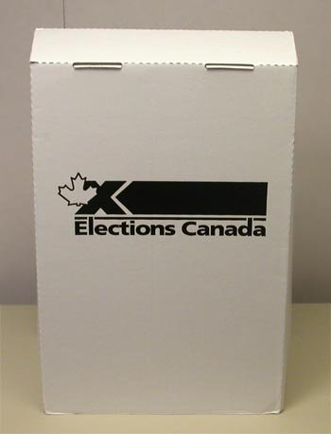

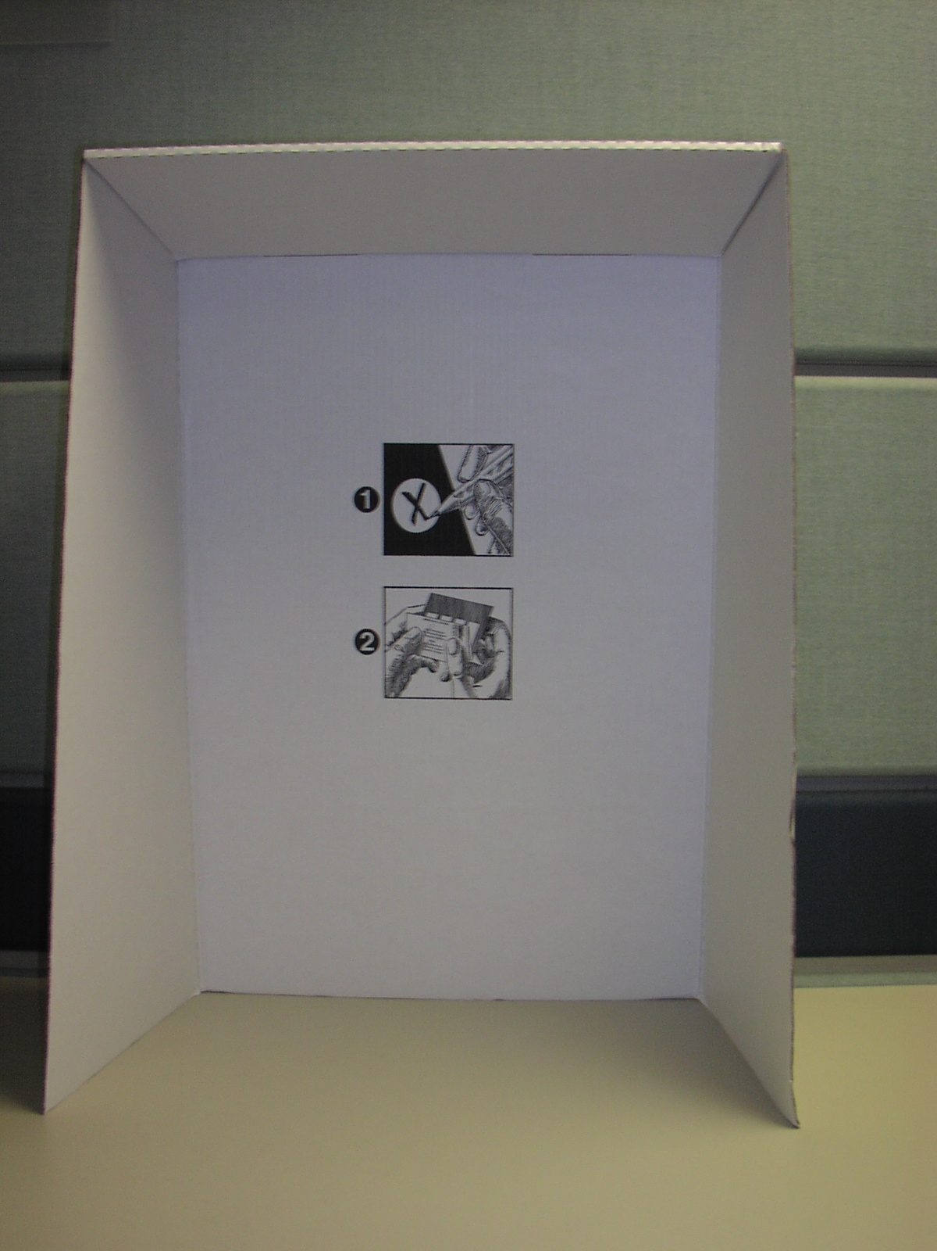

**APPENDIX C**

**WRAPPING - Label Sample**

|  |
| --- |
| ***EC 50240 (08/01)***  *Voting Compartments /*  *Isoloirs* *Quantity/Quantité - 10* |