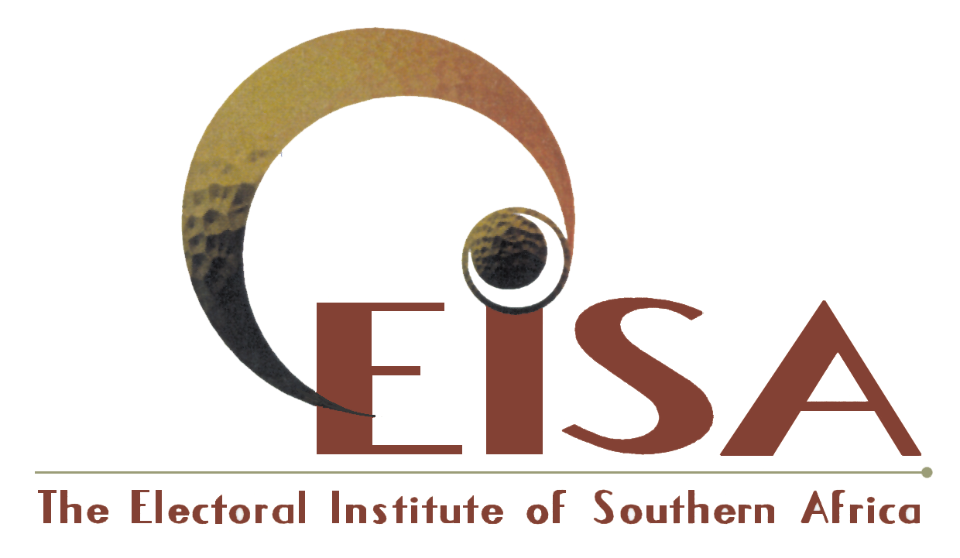

2nd Floor • The Atrium Telephone +27-11-482 5495
41 Stanley Avenue • Auckland Park Fax +27-11-482 6163
P O Box 740 • Auckland Park 2006 Email eisa@eisa.org.za
South Africa URL www.eisa.org.za

ELECTORAL INSTITUTE OF SOUTHERN AFRICA

Lilongwe, May 22, 2004

INTERIM Statement by the EISA Election Observation Mission

Malawi Parliamentary and presidential Elections May 20, 2004.

1. INTRODUCTION

At the invitation of the Malawi Electoral Commission (MEC), the Electoral Institute of Southern Africa (EISA) deployed a mission to observe the Malawi 2004 Parliamentary and Presidential Elections. This is the mission’s preliminary assessment of the elections. The assessment covers the pre-polling, polling, counting and the early stage of the tabulation of results. The mission cannot make any pronouncement on the overall post election phase at this stage. However, EISA will continue to follow the process so that the final report can provide a comprehensive assessment of the electoral process, including the announcement of the results.

  - About EISA

EISA is a regional organisation which seeks to strengthen and promote electoral processes, good governance and democratic values through research, capacity building and advocacy. The head office is located in Johannesburg and the scope of its work covers the entire SADC region and extends beyond.

  - Mission Composition

The mission was composed of 36 members drawn from electoral commissions, civil society organisations and scholars from nine SADC countries namely Angola, Botswana, Democratic Republic of Congo, Lesotho, Mozambique, Namibia, South Africa, Tanzania, and Zimbabwe. The mission included also few delegates from beyond the SADC region.

Sir Ketumile Masire, former President of the Republic of Botswana and Patron of EISA led the mission. The Deputy Mission Leader was Mr Denis Kadima, the Executive Director of EISA.

Members of the EISA mission started arriving in Malawi on May 9, 2004. The mission met various Malawian election stakeholders and observed events until May 21, 2004. The entire mission will have left the country by May 24, 2004.

  - Deployment

The mission deployed ten teams to the three regions of Malawi as follows: (a) two teams in the Northern Region, covering selected rural and urban areas namely Mzuzu, Nzimba North and Nkhata Bay (b) five teams in the Central Region, covering Lilongwe City, Lilongwe North, Mchinji, Salima and Dowa and (c) three teams in the Southern Region observing the process in selected areas of Blantyre, Limbe, Zomba, Thyolo, Mulanje and Mangochi. The Mission visited 181 voting stations in urban and rural areas throughout the country.

  - Method of Work

In order to assess the 2004 Parliamentary and Presidential Elections in Malawi, EISA conducted various activities covering the pre-election phase, the polling phase and will continue to follow post-election developments. These activities included:

Election Update

Due to limited financial resources available, it was not possible for the mission to undertake long-term observation. EISA developed an innovative method of information gathering and sharing that would ensure that members of the mission and other interested parties were kept abreast of the events which took place during the electoral process. Malawi based researchers were contracted to gather information on critical election-related matters. This information was published fortnightly in Election Update series, which was widely distributed electronically and in print.

Stakeholder Meetings and Political Party Rallies

Members of the mission held meetings with various electoral stakeholders, including representatives of the Malawi Electoral Commission (MEC), Political Parties, civil society organisations, the media and scholars. The mission also met domestic observer groups as well as other international observer teams. Meetings were held at both national and regional levels. These meetings provided first hand information on the different stakeholders’ assessment of the process.

Our teams also attended political party rallies. After the High Court ordered the postponement of the polling, the mission had an opportunity to observe the voters’ roll inspection process that took place between May 14 and 19.

Observation of Voting and Counting
The members of the mission were deployed in the field from May 16, 2004 where they held further meetings with election stakeholders before observing the voting and counting on May 20, 2004.

  - Principles for Election Management, Monitoring and Observation in the SADC Region

The EISA Observer Mission’s assessment of the Malawi 2004 elections is based on the Principles for Election Management, Monitoring and Observation in the SADC Region- PEMMO. PEMMO is a set of guidelines against which an election can be measured to assess whether it is credible and legitimate and if the outcome reflects the will of those who cast their ballots. PEMMO was developed by EISA in partnership with the Election Commissions Forum of SADC Countries (ECF), which comprises all the electoral management bodies in the SADC region. These principles are the result of a region-wide consultation process with electoral stakeholders, in particular electoral management bodies and civil society organisations for whom election observation is a core activity. The principles contained in the PEMMO are compatible with the legal framework governing elections in Malawi.

The principles cover the whole electoral process including the period before, during and after the poll. They provide an objective standard against which an election can be measured. Furthermore, they constitute a useful tool in the post-election review and for electoral reforms. For the observer, PEMMO also serves as guidelines for how to conduct oneself as an observer during the electoral process.

After the April 2004 national and provincial elections in South Africa, the Malawi 2004 Parliamentary and Presidential Elections are the second elections where EISA has used PEMMO as the basis of its assessment.

2. FINDINGS OF THE MISSION

The EISA Election Observer Mission, basing itself on the PEMMO as a guideline, made the following findings.

2.1. Voter Registration and the Voters’ Roll

By all accounts, the voter registration process was deficient, resulting in inflated voter registration figures. The cleaning process resulted in a computerised voters’ roll which contained other deficiencies including omission of names and photographs. In order to deal with this problem, the MEC used three reference documents to identify eligible voters during the voting process namely, the computerised voters’ roll, manual voters’ roll of 1999, and record cards. This caused confusion, delays and possible disenfranchisement of voters.

In addition, complaints by voters whose names did not appear in the roll were not addressed in a consistent manner in the various polling centres and no corrections seemed to have been made in spite of the extension of the inspection period.

2.2. Media Coverage
The mission was concerned by reports of unbalanced coverage of the elections by the public media in favour of the ruling party. Although the electoral law provides for the enforcement of media guidelines by MEC, the Commission seems to have failed to ensure fair media coverage for all parties and candidates.

  - The Malawi Electoral Commission

The Malawi Electoral Commission is constitutionally empowered to supervise and deliver credible, free and fair elections. However, the composition and procedure of appointment of the commissioners along party lines has resulted in the current situation whereby the commission is largely perceived as partisan. As a result, what could be genuine administrative and logistical shortcomings of the MEC can be interpreted as deliberate attempts to manipulate the electoral process. The Mission noted that the direct dependence of the MEC on the government for its funding has the potential to further compromise its independence vis-à-vis the incumbent government. It was also noted that Electoral Commission appeared to be unwilling to fully exercise the powers vested in it by the constitution and the Electoral laws (i.e. access to public media). Furthermore, the Commission seemed to lack the institutional capacity to organise and manage some crucial aspects of the electoral process such as the compilation of the voters’ roll.

2.4. Use of Public Resources by the incumbent government
The mission received many complaints that the ruling party took advantage of its incumbency to campaign for its candidates using public resources.

2.5. Constitutional and Legal Framework
The constitutional and legal framework in Malawi guarantees fundamental freedoms and human rights. In addition, the Electoral Law provides for mechanisms to address conflict in the electoral process. If fully implemented, this framework would further contribute to creating an environment conducive to free and fair democratic elections.

The mission applauds the role played by the judiciary during this electoral process by its timely adjudication of election related court cases.

2.6. Electoral System and Representation of Women
Malawi has adopted the Single Member plurality electoral System. The mission noted that whilst the system appears to have allowed independent candidates to contest the elections, it has failed to promote meaningful participation of women as candidates. The mission was concerned by the fact that only 154 out of 1268 candidates were women (12%) It should be recalled that the SADC Blantyre Declaration on Gender and Development advocates a minimum 30% representation of women in decision making positions.

2.7. Voting Atmosphere
The mission commends the people of Malawi for their commitment to democracy as demonstrated by their peacefulness, patience and enthusiasm during the voting.

2.8. Voting Stations
The mission was satisfied that MEC established enough polling stations to give voters easy access to the poll. In addition, the layout of the polling station allowed a smooth flow of the voting process as well as ensuring the secrecy of the ballot.

2.9. Intra-party Democracy

The mission received reports and information that the selection of candidates by political parties was not conducted in a democratic manner.

- RECOMMENDATIONS

The EISA mission encourages electoral stakeholders in Malawi to build on the positive experiences of these elections.

At the same time, the EISA mission calls upon all the electoral stakeholders to conduct a thorough post electoral review which would help the country improve on the conduct of future electoral processes.

Specifically we recommend the following
- The Electoral Commission should consolidate all the voters’ roll and documents in order to produce one accurate and reliable register of voters which would be updated continuously. In addition the Commission should consider having a continuous voter registration process.
- The electoral stakeholders should agree on an appropriate framework to ensure equitable access to the public resources by all contesting political parties and candidates.
- The Commission should put in place the necessary mechanisms to enforce media regulations pertaining to the electoral process so as to ensure equitable access to the public media for all political parties and candidates.
- For greater financial independence, the MEC should be adequately funded and accountable to Parliament.
- The mission recommends that the political parties adopt clear democratic principles in line with the PEMMO in the selection of their election candidates. These principles should include provisions for gender balance.
- In order to ensure consistency in the provision of voter education, the MEC should provide overall guidance and supervision of all role players in voter education.

4. CONCLUSION

Basing itself on the guidelines enshrined in the ECF/EISAPEMMO, the EISA Election Observer Mission concludes that the elections in Malawi were substantially free. The mission notes however that the playing field was not levelled, which made it difficult for opposition parties and candidates to have equitable access to public resources including the state media.

The mission will issue a final report within the next two months which will be distributed to a wide range of electoral stakeholders in Malawi and abroad.

Finally the mission wishes to congratulate the people of Malawi for their peaceful and orderly participation in the elections.

……………………………………………….. …………………………………..
Sir Ketumile Masire Denis Kadima
Mission Leader Deputy Mission Leader

Contact Persons
Denis Kadima +27 82 855 6136
Sa Ngidi +27 72 718 5071

