VOTING 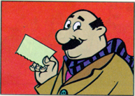 IS EASY
Here are the simple steps for voting

First, a committee member will check your identification against the Voters’ List, fills in the data of your identification besides your name and number and besides that you sign.


Second, the next committee member hands you a CLEAN ballot, and notes on the coupon your number according to the voters’ list, you then sign the coupon.

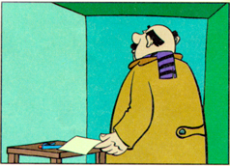

Third, Proceed to the secret voting booth with your ballot, make a mark in the circle next to the candidate you wish to vote for president, Do not make any other mark. Fold your ballot. YOUR VOTE IS SECRET, NO WILL KNOW WHO YOU VOTED FOR!


Fourth, Bring your folded ballot to the committee member accepting coupons and tear off the coupon in his/her presence and hand it to him/her.

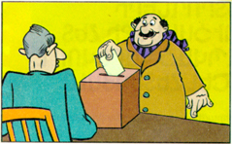
Fifth, After he/she has checked that the coupon is signed and stamped, he/she will open the ballot box. Drop your folded ballot in the box and exit the polling station. YOU HAVE NOW VOTED!

IMPORTANT THINGS TO REMEMBER
Make sure to make yourself an informed voter prior to going to the polling stations on March 16th, become familiar with the candidates and their platforms and proper procedures for voting
Remember to take your passport or identification with photograph to your polling station on Monday, March 16th from 800am to 1000pm to vote for your president.
Carefully check ballot to ensure it is clear of all markings prior to entering the voting booth.
Mark the ballot in the circle next to the candidate of your choice. Only ballots that are marked once in the circle are valid.
Election Commission and International Observers are here to protect the secrecy of your vote.
Important notes about the Voters’ List
You should go register prior to Election Day as well as ensure your name is on the Voters’ List.
The Precinct Electoral Commission makes the Voters’ Lists public by March 1st.
Should your name not appear in the Voters’ List , you can make a request to be added at the Precinct Election Commission. The Chairman of the Precinct Election Commission can make changes to the Voters’ List on Election Day upon the presentation of passport and proof of residence by the voter.
If the request for addition is declined you will receive a copy of the Precinct Election Commission decision. The decision may be appealed directly to a district court.
Decisions made by the district court must be implemented immediately.

