EAST TIMOR

PRESIDENTIAL ELECTIONS

14 APRIL 2002

EUROPEAN UNION

ELECTION OBSERVATION MISSION

FINAL REPORT

Contents
1 Chief Observer's Overview 3
2 The European Union Electoral Observation Mission 4
3 Political Background 5
3.1 Review of political developments since the Constituent Assembly elections 5
3.2 The Drafting of the Constitution 6
3.3 Features of the Constitution 6
4 Institutional and Legal Framework of the Presidential Elections 7
4.1 Organisation 7
4.2 Eligibility for voters and candidates 8
4.3 The Returnees 8
5 Registration of candidates 8
6 International and National Observation 9
6.1 International Observation 9
6.2 National Observation 9
6.3 Party Agents 10
7 General Electoral Issues 10
8 Pre-Election Observation including the Election Campaign 11
9 Civic and Voter Education 12
10 Election Day 12
10.1 Observations on Election Day 12
10.2 The absence of an electoral register 13
11 The Count 14
12 The Media 15
13 Recommendations 16
14 Future Prospects for East Timor 17
15 Annexes 19
15.1 Biographies of the Candidates 19
15.2 List of Political Parties 21
15.3 Code of Conduct & Conditions of Operation for Electoral Observers in East Timor 23
15.4 List of Observers and Their Deployment 27
15.5 Key Press Statements 28
15.6 List of Media Interviews 32
15.7 List of Contacts by the Core Team of the Mission 32
15.8 Official Election Result 33

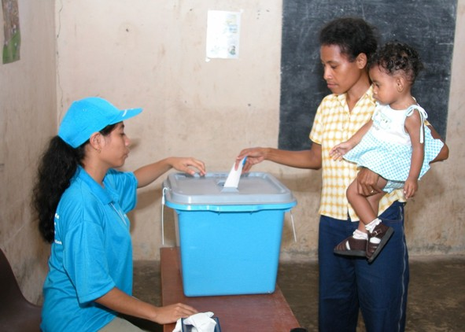

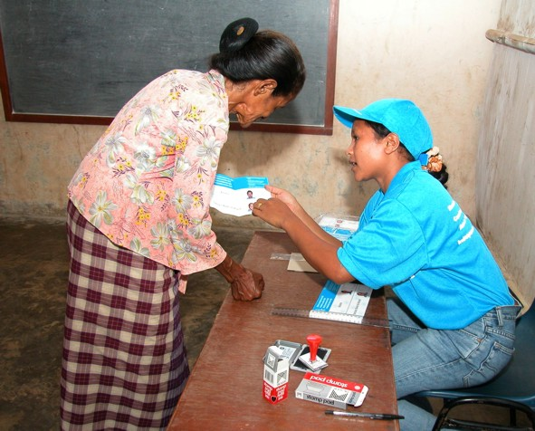

"Fully conscious of the need to establish a democratic and institutional culture of a lawful state, where the respect for the Constitution, for the law and for demo-cratically elected institutions should be its unquestio-ning base…"

Preamble to the Constitution of East Timor

Chief Observer's Overview

“E QUINDO USCIMMO A RIVEDER LE STELLE” Dante
Timor Loro’sae has emerged from its nightmare “to rebehold the stars”. The last piece of the constitutional jigsaw, before reclaiming Independence was the election of its first President. Now it becomes the first new Nation of the Millennium. From 1702 it was a Portuguese colony. The year of 1975 saw, in rapid succession, Portuguese evacuation, electoral success for those wanting independence, the declaration of that independence and the invasion and annexation by Indonesia. Then followed years of resistance and retaliation, with some 200.000 East Timorese losing their lives. More died and great was the destruction of homes, hospitals, churches and public buildings after the 1999 plebiscite.
On Election Day, the 14th of April 2002, I stood above Manatuto and looked down on the roofless and partially rebuilt homes, in which live a remarkable people. Like their brothers and sisters throughout the eastern half of this their island, they have come through it all; they had been to vote early in enormous numbers; they looked to the future with apprehensiveness but with determination. They need our continuing support, to ensure their physical security, their economic wellbeing and their democratic future; but they are free, they are independent and they have a remarkable story to tell.
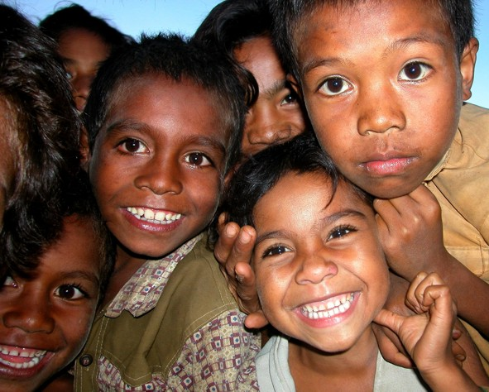

The future of the Nation – the East Timorese children
East Timor looks to the world for donor and know-how support; it has strong links with Australia and developing ones with Japan; ASEAN is a partnership it will probably seek. But it is to Europe that it particularly looks for support. Britain and Portugal have already announced full Embassy ties and Ireland has strong links. It was right therefore that the European Union should send the largest team of election observers and with two observers in every District, including the Oecussi enclave in West Timor. The team I was privileged to lead had members from every EU Member State. We were there to assess the electoral process and the acceptability of the result; but we were also there as the outward and visible sign of the EU's continuing commitment to East Timor and its future.
We were grateful to all those who made our mission a success; our thanks to the previous EU missions (at the plebiscite, the constituent assembly elections and the preparatory team for this election); also for the help from the United Nations agencies – UNTAET, UNDP and UNHCR and others – who gave logistical and advisory support; our EU offices – ECHO, Portugal, Britain and Ireland – who shared the knowledge they had built up; the cooperation of other observer groups – not least the local Timorese, many supported by the Asia Foundation and those from overseas, such as the Australians, Japanese and American and, of course, the separate three-man Portuguese team and their team of Portuguese language teachers, with whom we had excellent relations. My particular thanks go to my team of long and short term observers, our Timorese staff and the Trojan trio of my core team, Antonio Menezes, Peter Erben and Michel Paternotre.
There were a number of problems before and during the election, which could have had an adverse effect on the outcome. The weather was one; the rainy season is not ideal for outdoor campaigning or voter mobility. The absence of an electoral register and the visibility of proof of having voted were others. The only mischievous element was the suggestion from some quarters that one could vote for both candidates. Our early warning about this proved to be both effective and welcome, as confirmed subsequently by nearly all the leading players. In some parts of the Country there was an undercurrent of fear, exacerbated by the quasi-militaristic activities of a small number of disenchanted groups and there were concerns expressed about the length and distance of the count. None of these proved of significance for the election outcome, even if they need to be addressed for the future.
Overall, as we said in our preliminary statement after the declaration, this was an election result in which we could have full confidence. That is to the credit of the Timorese people and of the Timorese staff, who began the process of taking responsibility for the electoral processes. It is also to the considerable credit of the new President, Xanana Gusmao and his defeated opponent, Xavier do Amaral for their civilised and unifying campaign. We wish them, the new Government and the people of East Timor all success, as they move into this new chapter in their Nation’s history.

The European Union Electoral Observation Mission
European Union Observation Missions have been present in East Timor at the 1999 referendum and at the 2001 Constituent Assembly elections. Furthermore the EU has contributed significantly to voter and civic education projects, in line with the EU's policy of strengthening local capacity for election management and observation.
A European Commission Needs Assessment Mission visited East Timor in January 2002 to appraise the pre-election situation. It concluded that an electoral observation mission would be useful and feasible, in order both to monitor democratic progress and to express the continuing support of the European Community for East Timor. UNTAET extended an official invitation to the EU that month. This was agreed, not least because it was expected there would be a reduced coverage by other international observation missions.
The EU Electoral Observation Mission’s purpose was, therefore:
- to express the international community’s interest in and support for the democratic process;
- to assess the electoral process, according to internationally accepted standards; and
- to enhance the transparency of the electoral process and the confidence of the candidates, political parties and the voters in the process.
In addition, an EU presence was even more needed at this stage when the Timorese people would be more involved in managing the actual election.
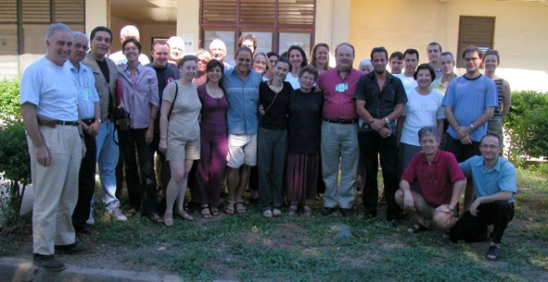

The EU Observation Team
The Core Team consisted of: John Bowis, Member of European Parliament as Head of Mission and Chief Observer, Antonio de Souza Menezes as Deputy Head of Mission and Deputy Chief Observer, Peter Erben as Observation Coordinator and Michel Paternotre as Logistics and Security Advisor.
UNDP was selected as the implementing agency to coordinate and support the Observation Mission. The Mission was based in Markas Compound, Dili, next to the UNDP Electoral Assistance Project and thus benefited from its logistic support as well as the corresponding interface.
The Core Team was operational from the end of March 2002, thanks to the presence of the Logistician, who was in place a month prior to the election, until the end of April when the office was closed.
For further information about the organisation of the mission please refer to Annex 15.9.

Political Background

Review of political developments since the Constituent Assembly elections
On the 14th of April 2002, with the holding of presidential elections, East Timor took the third and final step towards the establishment of democratic institutions in the country prior to independence.
Earlier on the 30th of August 1999, in a UN-supervised referendum, the people of East Timor, in a massive turn out of 98.5%, exercised their democratic right, in spite of intimidation and violence and voted by some 78% for national independence.
In the aftermath, those who refused to accept the popular verdict, unleashed a savage wave of terror with the murder of hundreds of people and a trail of destruction of homes, hospitals and public and private property throughout the territory. Some 200,000 East Timorese fled to West Timor, creating instability in the border region. The consequences of this period will mean a heavy price for the Country for many years to come.
The UN intervention, through the multinational force (INTERFET), and later the Peacekeeping Force (PKF), restored a degree of calm and stability. A UN Transitional Administration (UNTAET) was established in October 1999 headed by the Special Representative of the Secretary General (SRSG) Sergio Vieira de Mello with the task of preparing the Country for independence.
UNTAET, working closely with the East Timorese Transitional Administration (ETTA) and the National Council (a cross section of East Timorese political figures), organised elections for the Constituent Assembly in August 2001. 16 parties and 5 independents contested the election. The turnout was 94.6%. In the 88 members Constituent Assembly 12 parties and 1 independent are now represented.
After 8 months of deliberation and public consultation, the Constituent Assembly adopted the Constitution on the 22nd of March 2002.

The Drafting of the Constitution
In drafting the constitution emphasis was placed on engaging a broad cross section of the population in the constitutional development process. Through the directive of the SRSG, Constitutional Commissions were set up. The aim of this process was to strengthen the community’s sense of ownership of the resulting constitution and also of its commitment to abide by the constitution.
Over 37.000 people turned out at 200 public hearings in the 65 sub-districts between the 18th of June and the 14th of July 2001. The Commission’s findings were presented by the SRSG to the Constituent Assembly in September 2001.
The draft Constitution was completed in February 2002. The date of independence was hotly debated, as between the 28th of November, which was thought by some to favour one party (FRETILIN) and the 20th of May. Eventually the Constituent Assembly settled for the latter. The Constitution in its preamble states: “the independence of East Timor proclaimed by FRETILIN on the 28th of November 1975, now internationally recognised on the 20th of May 2002, as the liberation of the Timorese people from colonialism and from the illegal occupation of the Maubere Motherland by foreign powers had been achieved”.
The reports on the hearings and written submissions were considered by the Systematisation and Harmonisation Committee of the Constituent Assembly, which completed its review in early March 2002. Among the submissions was one from the group called Defend Democracy, Peace and Stability (GDDPETL), who objected to the Constituent Assembly transforming itself into the first Legislative Assembly and demanded new elections. This has been one of the more controversial issues between the political parties.
Changes made to the Constitution included: the oath referring to God and people, slight changes to the colour of the flag and that the national anthem be “Pátria Pátria”. On religion it stated that “there shall be no official religion of the State” and that “the State shall respect the different religious denominations that are free to organise themselves and exercise their activities”. Tetum, the national language of over 60% of Timorese, and Portuguese were declared the two official languages, while Bahasa Indonesian is widely spoken and English increasingly so among the younger generation.
The Constituent Assembly decided to transform itself into the Legislative Assembly after independence. The Constitution was signed by every member of the CA and adopted on the 23rd of March 2002. The two candidates in the presidential election also witnessed the ceremony.

Features of the Constitution
The constitution has echoes of the Portuguese constitution and largely reflects the political thinking of the Fretilin party, with its large majority in the Constituent Assembly (55 out of 88). Other parties would have preferred a more balanced distribution of powers between the Executive and the President. The latter now has to derive his authority from the popular mandate at the polls and on the influence his personality can bring to bear on the government.
It will be a cohabitation very much conditioned, not only by the Constitution, but also by the constraints and the predicament in which the country may find itself after Independence and after the departure of the UN Transitional Administration.

Institutional and Legal Framework of the Presidential Elections
In order to “implement the decision of the people of East Timor in the Constitution” the Transitional Administrator (SRSG) on the 16th of January 2002 promulgated Regulation 2002/1 “For the purpose of electing the first president of an independent and democratic East Timor and for making certain amendments to UNTAET Regulation No. 2001/2". Hence the electoral regulation 2001/2 from the previous election was still in force.
Further supplementing this legal framework, Regulation No. 2002/2 was passed the 15th of March 2002 "on electoral offences in relation to the election of the first president.

Organisation
The Independent Electoral Commission (IEC) was once again asked to organise and supervise the elections set for the 14^{th of} April 2002. The election was to be by universal suffrage, in a secret ballot and on the basis of a single national constituency. There would be no electoral register.
In keeping with the UNTAET and IEC overall objective of devolving to East Timorese the management and administration of elections, the Independent Electoral Commission was now composed of a Chief Electoral Officer and 5 Commissioners of whom three were East Timorese including the Chairman and two were international.
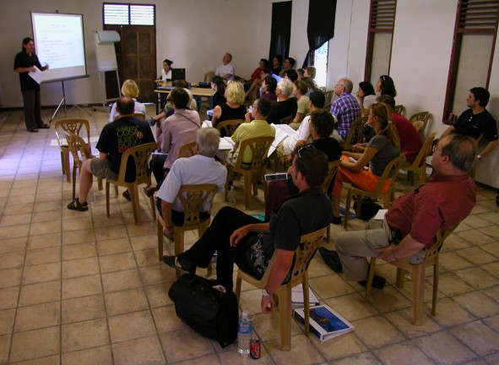

Carlos Valenzuela, the Chief Electoral Officer brief the EU Observers on the role of the IEC
The election operation was implemented by the Chief Electoral Officer, Carlos Valenzuela (also in charge of the 2001 election) and his organisation, with its headquarters in Dili managing the 13 District Offices. One of the most noticeable achievements of the organisation was the comprehensive capacity building program, which had introduced capable East Timorese election staff throughout its structures. As an example; Each district was for this election formally headed by a national District Election Coordinator supported by an International District Advisor (One drawback was that the latter in some cases was found to be too dominating, not leaving enough room for the Coordinator to manage him/herself).
Half of the 282 Polling Centres were supervised by a national District Election Officer, while the other half was supervised by Internationals. About 6000 national staff competently ran the actual 993 Polling Station (contained within the 282 Centres).
Regardless of the significant participation of national election officials it remained evident that the final say at most levels was with international organisers. The question is whether it would have been possible to have advanced capacity building further by ensuring that more responsibilities – for example at the count – were devolved to Timorese staff

Eligibility for voters and candidates
The criteria were the same as in the election of August 2001 for the Constituent Assembly: persons aged 17 or above on Election Day, born in East Timor or born outside East Timor, but with at least one parent born in East Timor, and persons whose spouse meets either of the two previous criteria.
There was no electoral roll in this election. Those eligible to vote simply had to show proof of registration with the UNTAET Civil Registry on election day and this registration could be done up to polling day.
In the case of party candidates, they had to prove that they were 35 years old, born in East Timor, that at least one parent was also born in the country and that they maintained primary residence for at least 6 months prior to the candidacy.
Independent candidates had to meet the same requirements as the party candidates and additionally present 5,000 signatures of eligible voters supporting the candidacy.

The Returnees
In this election there was a concerted attempt to make eligibility to vote as inclusive as possible and to extend it to East Timorese refugees in West Timor. The only requirement in the latter case was to register on their return, either at the UNHCR posts set up for the purpose or at their district office. This facility prompted a surge in the number of returnees during the months of March and April. In effect registration went on all the way till Election Day. Leading political figures - the SRSG, the Chief Minister, the Presidential Candidates, Bishop Belo – made public appeals to the refugees to return to participate in the elections. Xanana Gusmão visited some of the refugee camps to deliver this appeal personally. It is estimated that about 45.000 are still remaining in West Timor, but it is thought that not all of them will eventually return, mainly because of their connections with the former Indonesian regime.

Registration of candidates
Xavier do Amaral was nominated by PARENTIL (Partido Republika Nacional Timor Leste) and by ASDT (Associacao Social Democrata Timorense). On the last day of the deadline for nominations Xanana Gusmão announced his candidacy nominated by 9 parties, namely PSD (Partido Social Democrata), PD (Partido Democratico), UDT (Uniao Democratica Timorense) KOTA (Klibur Oan Timor Asswain), PNT (Partido Nasionalista Timorense), PST (Partido Socialista de Timor) UDC/PDC (Partido Democrata Cristao), PTT (Partido Trabalhista Timorense), and PDM (Partai Demokratik Maubere).
There was considerable controversy on whether the ballot paper should include the symbols of the nominating parties. The IEC initially acceded to the request of the parties nominating Xavier do Amaral, but Xanana Gusmão objected, on the grounds that although he was nominated by 9 parties, he was an independent candidate and as such he did not want their symbols on the ballot paper. He threatened to withdraw from the election on this issue. It was eventually resolved by Xavier do Amaral's nominating parties agreeing to drop their symbols.

International and National Observation

International Observation
In total approximately 38 international observation groups, fielded about 396 accredited observers, registered formally with the IEC. Many of these were existing NGOs, some sponsored by American external groups, and bilateral missions in Dili with fewer than ten observers. None covered all Districts, as the EU was able to with its 40 strong observer Mission. The only other monitoring team covering most of the Country was a Portuguese group of Portuguese language teachers. This team wished to be seen as separate from the main EU team and we had friendly discussions with their leaders. They did not at the end of the election release an opinion separate from the EU.
We established good relations with the major local and international groups, in order to share views and assessments of other players. This was done through regular contacts on both Chief Observer and Coordinator level and by a meeting we hosted at the end of polling with colleagues from Australia, America and Portugal.
The reports released by all groups were largely in agreement with us on the assessment of this electoral process.

National Observation
78 National observer groups registered totalling 1817 observers, many groups being fewer than 20 in number. We established a close cooperation with the larger groups and met with them individually and in a "forum", both before and after the election, to discuss common interest and observations. Within the very limited time available we tried our best to assist them in term of methodology which was clearly an area in need of development.
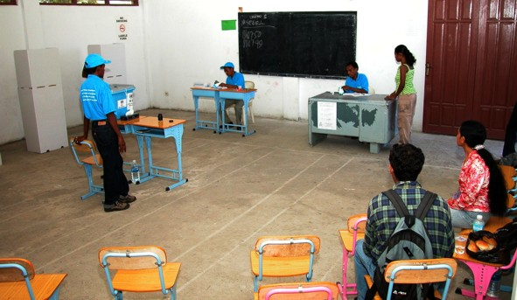

A Polling Station observed by National Observers (right lower corner)
UNDP Electoral Assistance ran an excellent programme in support of the National Observer, which provided them with good briefings, documentation and visibility materials. More national observers registered than actually turned up on Election Day. This is probably due to the fact that, over the three elections, some international funding has been available for selected NGOs and some joined in the hope of gaining access to funding. Furthermore, there is no legal requirement to register as a NGO with the government before seeking accreditation, which makes it extremely easy for anyone to go to the EIC and present themselves as an NGO and request accreditation. Equally there was no requirement to vouch for the independence of any individual claiming to be an observer.
The National Observer groups are largely acting independently, with little or no cooperation between them, beyond the “Asia Foundation” umbrella. There is no forum that can produce a more coordinated assessment of the electoral process. A network of NGOs involved in this area needs to be developed so that they carry authority.
We recommend that there be a dialogue within the international community to develop a more coordinated national observer scene, perhaps by funding and training one or several election observation fora. Such an approach might prove difficult simply because of international inter-agency competition. It was bizarre how some American organisations jumped the gun to put out an early statement, irrespective of the interests of objective monitoring.
Nevertheless, a considerable enthusiasm was evident among the national observers present in most Polling Stations, which certainly contributed to the integrity of the process on Election Day and, later, during the count.
A closer cooperation with national observers should be considered, perhaps working in partnership or in parallel with them and helping to fund their experience gathering.

Party Agents
Observation by party agents at the polling stations was fairly effective, although not all of them seemed to understand their role. The main political parties were represented as well as the presidential candidates. When it came to accompanying the ballot boxes to the counting centres, not many party agents did so and, in some cases, none were available when the boxes were left for overnight custody. The reason alleged was that they were too tired after a long day and that transport was not always available to the district centre. The surveillance of the boxes at this point was largely left to national or international observers.
If the system of counting at the district centres continues in the future, although most political parties prefer polling centre counts, there is need for greater supervision by party agents of the escorting of the ballot boxes to the count.

General Electoral Issues
The general UNTAET approach has been not to pre-judge decisions the Timorese might take after independence. This has had significant impact on the establishment of sustainable electoral systems and institutions. It might have been better to focus on promoting good practices.
An example in East Timor is the absence of pre-independence discussion, consultation and decisions on the possible establishment of a local government structure. The absence of this means that the current electoral environment has no experience with local election processes and that current local election officials have no organisational framework within which to work.
A further consequence is that UNTAET, including the EIC, accepts that current election institutions may be dissolved after this election and that it will be up to the new Government to establish the basis for the future electoral system. It would be unfortunate, if the experience gained by the East Timorese Commissioners and election staff were to be lost and we would urge that this expertise be retained and nurtured.
In many areas there will have to be changes; voter registration, polling station designation and management, voters having to vote at a specific station and so on.
Critics might say that UNTAET choose an "easy" model, which left few sustainable election traditions behind. On the other hand the EIC is leaving capable, well educated and motivated human resources behind, especially in the lower ranges of the election administration where there is a significant group of capable Election Officers who could be included in future central and local election management bodies.
In the final days of our mission we learned that funds had been made available to retain yet to be defined election institutions. That is good news. They can then hold some institutional memory, continue capacity building, work with international technical consultants and make recommendations on electoral issues.
Inevitably and from all directions there have been allegations that the IEC is politically biased. We saw no evidence of this and we have faith in the existing well-educated national election technicians.

Pre-Election Observation including the Election Campaign
In the period leading up to Election Day the STOs and LTOs were tasked to look into very specific areas, for example to evaluate campaign events, alleged intimidation of voters, voter and election staff education, etc. The observations from this period are found throughout this report where they are thematically dealt with.
The dominant activity before Election Day was obviously the election campaign. Unlike the previous election of August 2001, the electorate clearly knew what it was about. To a large extent this was understandable, because the hero of national resistance, Xanana Gusmão was a candidate. Whereas the previous one was a battle between the political parties to achieve power, this was seen as a ritual contest between two historical and widely respected figures of East Timor in order to eventually “enthrone” the symbol of national resistance.
The political divisions reflected in the Constituent Assembly especially during the drafting of the Constitution did not spill over into the presidential campaign. In a display of national unity all the parties signed the Constitution and both candidates attended the ceremony just as the election campaign was getting under way.
The parties that backed each of the candidates played a low profile in the campaign although individual party workers were engaged in the campaign organization.
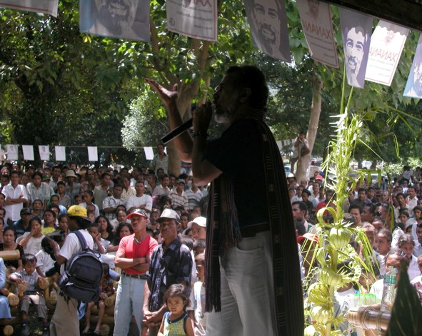

Xanana Gusmão campaigns
While Xanana Gusmão declared himself as an independent candidate, Xavier do Amaral behaved as such in practice. Both held the middle ground and there was hardly significant difference in opinion albeit nuance. The common themes were pluralistic democracy, national reconciliation, human rights and the role of the President under the Constitution.
It was a pale campaign in a calm atmosphere. The health condition of Xavier do Amaral, who only campaigned briefly and on various occasions cancelled his election engagements, made it even less eventful.
However the breach that existed between Xanana Gusmão and the FRETILIN leadership did surface from time to time with a mild frisson in the campaign. Although officially FRETILIN left it to the conscience of their party followers to decide how to vote, there were at the same time reliable reports that people were being told that since there were two good candidates, they could vote for both. Mari Alkatiri, the FRETILIN leader was reported as having made similar comments but corrected them later, indicating that he intended to cast a blank ballot paper.
It was at this point that the EU Chief Election Observer in a public statement warned the electorate not to be misled by such advice if forthcoming and that if carried through the validity of the electoral process could be compromised (See statement in Annex 14.5). A number of key players later expressed their gratitude for this statement, which they said had helped to prevent it becoming a major problem.

Civic and Voter Education
In a country where illiteracy is high, the education system weak, the media barely reaches the population, civic and voter education is an uphill task. Furthermore almost a quarter of century of alien military dictatorship only compounded the problem. Thus the task has to be done largely through informal forms of information dissemination, through traditional village structures, through the Church among others.
On the formal side UNDP which is funded by international donors including the European Union runs a civic education programme through closely monitored grants to NGOs. The Independent Electoral Commission voter education programme is also UNDP funded.
Some of the activities of the UNDP civic education included a weekly radio show with an interactive format that encouraged listeners to express themselves on a variety of election and civic education topics. Themes ranged from voter registration rules, to tolerance, to importance of women in democracy.
Although the UNDP programme only touches the surface at the moment, it is well thought out good start and could have a good impact if it could be long term. However this would require a more long-term commitment from the donors.

Election Day

Observations on Election Day
In general Election Day went above everyone's expectation, to the point where the entire electorate had almost voted in an orderly manner by midday. The most noticeable difference from the previous year was the well organised logistics and the expanded capacity building, which had a very positive effect in many areas, such as a timely opening of almost every Polling Station we observed. Good logistics, and the fact that processing the voters was extremely simplified by the absence of a register, meant that, as opposed to the previous election, there were no capacity problems and consequently no queuing problems. In a case like this an election administration could be accused of having misjudged (overestimated) the capacity needed to process the electorate, but we believe that due to the significant systemic changes from the previous year's election it could not be expected that the IEC would have foreseen and adjusted for this.
Apart from the voting in the prison there was no special needs voting programme facilitating voters who were homebound, handicapped, etc. While we understand that this is a fairly advanced election feature given the basic nature of the election that was conducted, we do believe that future consideration should be given to give these voters easier access to vote.
The 933 Polling Stations were concentrated in 282 locations, a system brought forward from the last election. This did lead to some voters having to walk for hours to vote, somewhat compensated for by the fact that many were going in that direction anyway to attend Sunday mass. We recommend that it is considered whether the Polling Stations cannot be somewhat more decentralised bringing the voter closer to the electorate.
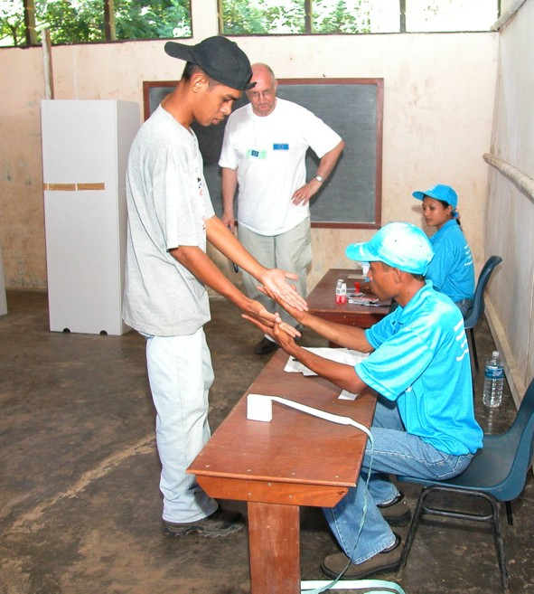

EU Observer keeps an eye on hands being checked for signs of ink
One interesting tendency was that many National Observers and Party Agents left the Centres when realising that no more voters would turn up, meaning that no one was observing the ballot box in the late afternoon and the reconciliation and transport of ballots after closing. Steps must be taken to emphasise that the process goes beyond the actual casting of the vote and that observation is needed all the way through to the delivery of the ballot box to a secure location.
Throughout East Timor other minor procedural problems were observed; voters not being instructed well enough, voting screens being poorly positioned, excessive assisted voting, etc. All irregularities observed in most emerging democracies and none having any real consequence for the integrity of the process and the result.
With a turnout of 86.3% (slightly lower than 2001) we believe that Election Day had a more than healthy voter participation and that the voters were well prepared for the event.

The absence of an electoral register
This election was carried out without an electoral register. The official explanation was that it made the event as inclusive as possible. In reality it was because the civil registry, from which the list of voters emanates, turned out to be so faulty during the 2001 election that the EIC decided that, given the short preparation time, it would not be possible to produce an accurate list from that source. A 2001 official external audit of the registry supports this view.
The absence of a voter's list was acceptable for this specific election, even though it lowered the technical standards. In a single constituency presidential election, place of residence was less relevant, the election was not overly contested and systematic fraud was not expected nor occurred.
To counter the absence of a voter register, visible ink to mark the fingers of those who had voted and stickers on the "proof-of-registration card" (not a true ID-card, but a printout with picture) were used to avoid fraudulent and, especially, multiple voting.
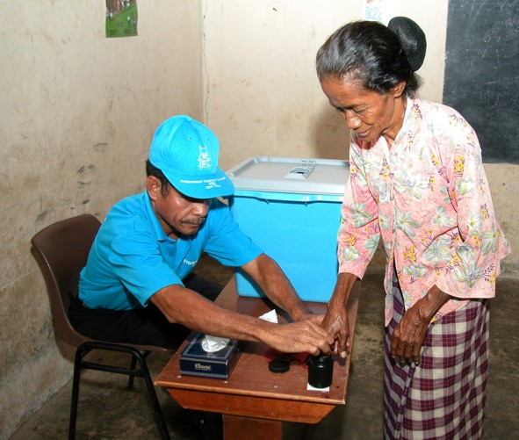

East Timorese voter gets her finger inked
The sticker came off fairly easily with little or no signs of the removal, especially on laminated "IDs". The photo on the printout was of such poor quality that it was dubious as identification of an individual. In many Centres the ink was not administered carefully and it was possible to wipe it off. In any case, if there had been intimidation to persuade people to vote or not to vote, the visibility of the ink would have been undesirable.
However, although the system for checking the voter's identity and eligibility and for preventing multiple voting was flawed, it is our opinion that this flaw was not exploited to any serious degree and that little actual fraud took place.
We recommend that steps are taken immediately to address the absence of a voters register and to consider the weakness of the voter identification system. The civil registry already has serious shortcomings. These may get worse, unless sufficient funding is provided for the purpose and international expertise needs to be offered after independence.

The Count
In general the count went well and few procedural mistakes were observed, none of which would seriously influence the integrity of the result. The count was finished much faster than the IEC had predicted due to a number factors; good organisation, simple ballot, etc. In a few districts the observers found that expediency was prioritised over procedural preciseness and that the process became too much of a "race".
The count was only done by the 300 District Election Officers. We believe additional counting staff, including, for example, teachers, could have been hired and trained specifically for the purpose. This would have enabled the count to proceed on election evening and be finished much earlier.
While we believe Election Day had an acceptable division of management of the Polling Centres between International and National Election Officers, we observed that the 13 district counting centres were dominated by international staff supervising the process with East Timorese staff acting in support. We should have likes to see national staff taking most of the central supervisory roles, advised where needed by internationals. Having seen many competent national Election Officers, we believe such capacities were available.
The count happened centrally at one centre per district. Some people were critical of this approach, saying that transporting the ballots before the count offered too many opportunities for manipulation and therefore seriously endangered the integrity of the election. They believed votes should be counted immediately after close of poll at the Polling Centre. The fact is that the two approaches, local or central counting, each have their strengths and weaknesses. While a local count can be faster and more transparent, it does reveal the political preference of smaller communities and is furthermore difficult to execute well with the low numeracy standards in some parts of East Timor. A central count offers more control, but also opens for more opportunities to tamper with the votes before the count.

The Media
One of the serious deficiencies that hamper public information and opinion forming debate, so necessary to build democratic institutions and practice, is the state of the media in East Timor.
At the moment the channels of public information are few and with hardly any professional expertise. UNTAET Radio is the one with the largest audience and reaches the 13 districts. This is probably to be turned into the state-broadcasting medium after independence. Television Timor Lorosae (TVTL) reaches only Dili and is the embryo of a future national TV station. There are two daily newspapers, which circulate in the capital (about 2500 copies) and reach the districts late and with difficulty, and two weeklies. A handful of local publications are produced in the districts. Community radio stations are on the air in Dili, Liquica, Maliana and Los Palos.
With such conditions and due to the fact that it is difficult to find good translators and interpreters locally, it was difficult for the Mission to assess what role and impact the media plays in an election. We had to rely instead on the Media Mediation Panel.
In the months preceding the Constituent Assembly elections of 2001 an independent Media Mediation Panel (MMP) was constituted as “a conduit for political parties, independent candidates and others” to air complaints and seek solutions regarding UNTAET's media coverage of the election campaign. The overriding concern was that the MMP be guided by a sense of fairness and impartiality in dealing with any complaints received. The MMP was funded by the UNDP Electoral Assistance Programme but functioned independently of UNTAET or any other UN organization.
The MMP operated again during the presidential election campaign from the 15th of March to the 14th of April. Any complaints received were to be passed to the Office of Communications and Public Information (OCPI)
Given that the presidential election was a contest between just two individuals, Xanana Gusmão and Xavier do Amaral; it would seem on the surface a simple matter to ensure fairness and balance. The deeper dilemma of the campaign was the question of overall political balance, which inevitably involved the interests of not just two candidates, who were technically running as "independents", but also of the ruling party, FRETILIN which did not field a candidate. Early in the campaign it became evident that FRETILIN had partisan interests in the outcome of the election and that long simmering differences between Xanana Gusmão and FRETILIN had come to the surface. It was MMP's view that there were in effect three candidates, Gusmão, Amaral and FRETILIN.
The political tension between Gusmão and FRETILIN became a feature of the campaign and led to frequent private and public charges from Gusmão supporters that partisan pro-FRETILIN journalists inside Radio UNTAET were slanting coverage against Gusmão. Conversely from FRETILIN activists complained that TVTL was “unprofessional”. However none of the interested parties chose to make a formal complaint to the panel regarding these perceptions of bias.
The MMP in its report referring to UNTAET and TVTL states that “there were political tensions among journalists but that management largely kept them out of the newscasts” and that coverage remained ”fair and balanced”.
The Public Broadcast Authority that will succeed UNTAET after independence will need to pursue political fairness and balance. The MMP recommends further that “interested parties from the private and public media, journalist associations, NGO's and donor agencies should consider forming a "media council" for the future in East Timor. This council could help mediate on complaints and enhance public perceptions of fairness”. We strongly support this recommendation in the interest of fair play and free debate particularly during election period.

Recommendations
We would like to make the following recommendations which the European Union might consider:
- The development of a complete election system must start now, which includes the establishment of the appropriate election management bodies. Whereas the outgoing Independent Election Commission prepared a large cadre of election officials and staff spread throughout the country, tested in three national polls and established sound independent and sound election practices, these should be preserved and built on for the future. We recommend that an Independent Electoral Body comparable to the IEC be directly appointed by the President of the East Timor Supreme Court and accountable to the Court.
- Every effort must be made to bring Civil Registry back on track so this can form a viable basis for the administration of not only a future voter's registry, but also many other governmental functions such as taxation, social benefits, etc. Further we recommend that immediate steps are taken to develop a viable local government structure. Such a process would be strongly dependent on demographic information provided by a civil registry.
- Whereas illiteracy is high, the education system weak and the channels of social communication incipient, to overcome this there is need of effective and sustainable civic education projects through local and international organisations. We recommend that donor should continue to support these projects with more substantial funding to ensure that the democratic process is reinforced.
- Whereas national observation is yet to come into its own due to lack of organisation and co-ordination we recommend that as part of civic and voter education projects national observers be trained and encouraged to channel their effort through one or more fora. Further, international donors and organisations engaged in observation should consider establishing “pilot mixed teams” of international and national observers, duly whetted.
- Whereas the European Commission Country Strategy Paper has set the priorities for co-operation with the new Independent East Timor for the next few years it is essential that in the period immediately after independence the European Union appears committed to strengthening its democratic institutions. We recommend that projects for capacity building should be actively encouraged and supported.
- The United Nations agencies have played a very significant role in most sectors during the years leading to independence. We believe that they should continue to be engaged in long-term strategies and that the international donors should support them more extensively.

Future Prospects for East Timor
If the election of 2001 for the Constituent Assembly decided the shape of the Constitution and eventually the rise constitutionally of FRETILIN to political power, this presidential election determines how this power will be exercised in the next few years. In the political scene of East Timor two different concepts of wielding power have been at play since the last election; one in which FRETILIN, having emerged as the largest party in the last elections, would be entitled to all the levers of power in the new administration (Alkatiri line) and the other in which the new government should be one of national unity or one in which other parties should also have a share at least at this initial stage of independence.(Xanana line) It was felt by many, bearing in mind the painful past of violent confrontation between the political parties in 1975, that consensus politics and checks and balances should be the order of the day.
Thus in the presidential elections the question below the surface was which line would prevail and it was put crudely in terms of percentage majorities obtained at the previous and the current election.
Xanana’s crushing victory at the polls and the generous and dignified attitude in defeat of Amaral (who appeared together with Xanana at the post election press conference) have now set the tone for political life. This was followed the next day by a lengthy meeting between the President elect (Xanana) and the Prime Minister in waiting (Alkatiri), who had been at odds in the past. It was apparently all sweetness and light and ended in close harmony. While it is accepted that the Constitution gives only limited powers to the President, the future government will now have to reflect also the counsel of the President, a cohabitation in uncharted waters.
This consensus will be all the more necessary in face of the mounting financial difficulties the country will face after independence. The downsizing of international staff, whose presence to some extent sustains the meagre economy, will also have some impact. Until the oil and gas revenues from Timor Gap become available in between 3 and 7 years, the country will have to bridge the shortfall in revenue with foreign aid.
There is a great expectation that the forthcoming Donor’s Conference in Dili before Independence Day will bail the country out, at least in its first year. It may also help to underline the fact that financial support comes from a number of international sources and not just the European Union. The new President also makes the sensible point that Eats Timor’s ability to spend is limited and that, therefore, aid should be measured and steady, rather than in large early doses.
A country of a predominantly young population with few job prospects could easily slide into social unrest and political instability. The current problem of those ex-Falintil militia who have been agitating to be incorporated in the new Defence Forces is basically one of employment and is typical of the situation in the rest of the country. Finding occupations for idle hands will need to be a priority in the coming years. The Bishop’s criticism to us of international NGOs, which come, take photographs, utter fine words and go away without creating any jobs, was well made.
In brief newly independent East Timor has three challenges ahead. One: how to defend its identity next to a powerful neighbour that is still reluctant to accept the new reality, especially when some other parts of Indonesia are also agitating. Two: how to survive economically, with internal peace and stability, until the oil and gas revenues arrive to develop the country and especially the human resources it so badly needs. Three: how to manage public expectations and to develop internal capacity to invest wisely over a period of years for the benefit of all the people.
These are challenges to the international community too, which has staked so much in the past few years to ensure that East Timor was not crushed and that their democratic right prevailed. The European Union – and other partners, such as Australia and Japan and ASEAN – need to be ready to support and advise but always respecting the fact that East Timor is now an independent and sovereign nation and must be allowed to develop its own identity and culture. We must all be careful not to try to impose our own.

Annexes

Biographies of the Candidates

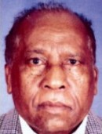 | Francisco Xavier do Amaral  Born Francisco Xavier do Amaral in Hululu village, Turiscai on 3 December 1935.  Amaral’s father was descended from the Kingdom of Maubisse, while his mother, a native of Turiscai, was the daughter of the second Timorese Brigadier General in the Portuguese army in East Timor.  A former school teacher and founder of the Fretilin, Amaral became the president of the short-lived Democratic Republic of East Timor (RDTL) Government, which was established by Fretilin. Amaral declared independence on 28 November 1975, nine days before the Indonesian invasion on 7 December.
Amaral was known at the time for his strong oratory style, and his ability to mobilise common villagers through use of both the Tetum and Mumbai languages.
Following the Indonesian invasion, Amaral retreated to the central highlands where he moved between Lequidoe, Aileu, and Turiscai.
In response to the widespread starvation of the civilian population in the mountains, Amaral argued that women and children should return to live in the cities, a policy which was not accepted by the Fretilin Central Committee. Amaral was arrested by the Central Committee and charged with collaborating with the Indonesians, in September 1976 in Mindelu, Turiscai.
In early 1977 he was captured by Indonesian Battalion 244 in Viqueque and held under house arrest in Dili. He was then moved to Bali where he was held under house arrest for four years. In 1983 Amaral was moved to Jakarta where the military housed him near the Kopassus (Special Forces) headquarters.
Amaral returned to East Timor on 4 February 2000, after fleeing Jakarta with the assistance of the Portuguese mission during the September violence. He spent a brief time in Portugal before returning from exile to his homeland.
Amaral reformed the Social Democrat Association of Timor (ASDT) in April 2001 as his new political vehicle. ASDT, the precursor to Fretilin, was originally formed on 20 May 1974. Following a brief alliance with the CPD-RDTL movement, Amaral separated ASDT as an independent political force.
ASDT has strong rural support in the Mumbai-speaking highlands of Aileu, Ainaro, Ermera, parts of Manufahi and rural Dili. The party received 8 percent of the total vote in elections for the Constituent Assembly in August 2001, making it the third largest part in the Assembly.
Amaral was nominated by two political parties, ASDT and PARENTIL, for this presidential election.

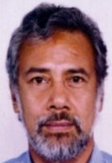 | Kay Rala Xanana Gusmão  Born José Alexandre Gusmão in Laleia, Manatuto, East Timor on 20 June 1946.  Gusmão attended the renowned Jesuit seminary in Soibada, Manatuto and later attended a seminary in Dare, in the hills behind Dili. During Portuguese rule in East Timor, Gusmão was a civil servant in the Department of Forestry and Agriculture.  In 1974, when the Portuguese government decolonised East Timor, Gusmão became a member of ASDT. Gusmão then became a member of the Central Committee of Fretilin and worked in the Information Department.
On 7 December 1975, Indonesia invaded and Gusmão with all the members of Fretilin and most of the population escaped to the mountains to resist the invading troops.
Between 1978 and 1979 when the majority of the Fretilin leaders and the leaders of Falintil were killed by Indonesian troops, Gusmão became the leader of Falintil. In March 1981 at a national conference to reorganise the resistance, Gusmão became the leader of the newly formed Revolutionary Council of National Resistance (CRRN).
In March 1983 the Indonesian commander in East Timor, Colonel Purwanto negotiated with Gusmão to find a peaceful solution to the conflict in East Timor. However, the new Indonesian Minister of Defence and Security General Moerdani ended these negotiations because Gusmão requested that a UN mediator be involved in the talks.
In 1987, following pressure from the Catholic Church, Gusmão declared Falintil a non-partisan ‘national’ army. In 1998 he relinquished membership of Fretilin and established the National Council of Maubere Resistance (CNRM), which grouped Fretilin, Falintil, the Catholic Church and UDT.
In November 1992, Gusmão was captured in Dili by Indonesian military and taken to Bali amid international protests. He was charged with subversion. In April 1993 an Indonesian court in Dili sentenced him to life imprisonment. Gusmão was sent to a political prison in Semarang in Central Java and moved to Cipinang Prison in Jakarta at the end of 1993. In 1994 President Suharto commuted Gusmão’s sentence from life to 20 years. Gusmão served 8 years of that sentence before being placed under house arrest.
In September 1999, Gusmão was released and sought refuge in the British Embassy in Jakarta. He was flown to Darwin and returned to East Timor to a triumphant welcome in Dili in October 1999.
Gusmão formed the National Council for Timorese Resistance (CNRT) in 1998 to replace the CNRM in a bid to unify competing political factions to end the Indonesian occupation.
CNRT held its first National Congress in August 2000. Relations between Gusmão and Fretilin visibly soured, specifically over whether the CNRT should be dissolved, a position that Fretilin firmly held. CNRT was finally dissolved on 9 June 2001 to allow political parties to operate in a competitive environment before the August 2001 election.
Gusmão was elected Speaker of the appointed National Council on 23 October 2001, and held the position for a few weeks until resigning. In 2001 he formed the Association of Veterans of the Resistance (AVR), to provide support and financial assistance to the clandestine members of the resistance and former CNRT members.
Gusmão was nominated for this election by nine political parties, however he has been adamant that the party symbols not appear on the ballot paper, and has run his campaign as an independent candidate.
Gusmão is married to Kirsty Sword-Gusmão and they have one son, Alexandre. Gusmão has two other children from a previous marriage.

List of Political Parties
Apodeti Pro Referendum – Associação Popular Democrática Timorense Pro Referendum – Popular Democratic Association of Timor Pro Referendum
The party was established on 27 May 1974 with the support of the Indonesian Government to promote “an autonomous integration into the Republic of Indonesia in accordance with international law”. It made a public declaration at the CNRT Congress in August 2000 accepting the results of the Popular Consultation of 30 August 1999 and adding “Pro Referendum” to the party’s name. It was a member of the Permanent Council of the CNRT until the organisation was disbanded. This is a minor party with a limited following.

ASDT – Associacão Social Democrata Timorense
Proclaimed on 20 April this year by Fretilin’s first President, Francsico Xavier do Amaral. The party takes its name ASDT from the association which spawned Fretilin in 1974. Amaral would like to see a restoration of the 1975 RDTL government, which he headed for nine days. Amaral’s strongest base of support is in the Turiscai and Maubisse areas, as well as the wider central mountain range. The party registered its own flag with the Independent Electoral Commission, following earlier plans to compete with Fretilin for their flag.

Fretilin
Arguably the party with the most extensive grass roots support. The party was formed on 12 September 1974 from the Timorese Popular Democratic Association (ASDT) which had been in existence since 12 May of the same year. Whilst the other parties formed in 1974 were essentially Dili-based or regional in scope, the ASDT/Fretilin set out to establish an organisation at a national level which drew on all sections of the rural population. Fretilin joined a short-lived coalition with UDT in 1975, which fell apart following a coup attempt by UDT, resulting in civil conflict. Fretilin declared unilateral independence for East Timor on 28 November 1975. The party was instrumental in continuing the struggle for independence after the Indonesian invasion and maintains its historical links with Falintil, the armed wing of Fretilin up to 1987. Fretilin formed part of the group of parties that signed the CNRT Magna Carta in Portugal in 1998. The party refused to join the Permanent Council of the CNRT after the August 2000 CNRT Congress, claiming that the CNRT should have dissolved to allow parties to flourish. The current leaders of Fretilin are Lú Olo and Mari Alkatiri, the latter being one of the two Fretilin members of the Transitional Cabinet (the other is Ana Pessoa). Fretilin has undergone a nationwide restructuring with village and sub-district level elections. The party held a National Congress from 11-15 July when delegates elected a new leadership of President Lu Olo, Deputy President Mau Huno and Secretary General, Mari Alkatiri. An 80 member Central Committee was also elected.

KOTA – Klibur Oan Timor Aswa’in
KOTA was formed in 1974 as a pro-integrationist party. The party philosophy is based heavily on traditional values and kings (liurai) of East Timor society. It held its congress of liurai in Dili on 15 May 2000 in which it called for a constitutional monarchy supervised by traditional elders and proposed that East Timor should continue under Portuguese administration until it was ready to become independent. This minor party has been active in both CNRT and the National Council.

PARENTIL – Partido Republika Nacional Timor Leste – National Republican Party of East Timor
This youth party was inaugurated on 12 February 2001 by a group of former members of the Student Solidarity Council. The party has no formal connections with the Council, which remains an independent NGO. The party’s motto is “People for People.” Parentil leaders state that they set up the party as an alternative to the older parties, run by the 1975 generation. The party has not yet developed a platform and has not nominated any district candidates. This minor party was one of only two which declined to sign the Pact of National Unity on 8 July.

PD – Partido Democrática – Democratic Party
The party declared itself on 10 June 2001 at a ceremony in Dili. Many members of the party are drawn from the youth resistance organisation, Renetil, as well as the former Internal Political Front of the CNRT. Renetil remains an independent NGO and is not affiliated to the party. The party leadership claims to have taken a large number of former CNRT representatives in the districts. The claim is supported by the party’s candidate list, which includes many former district CNRT officials.

PDC – Partido Democrata Cristão – Christian Democrat Party
The party was declared on 5 August 2000 in Dili as a meeting point for both Catholic and Protestant citizens. Initially the UDC, another Christian Democrat Party formed in Portugal was linked to the PDC (see UDC above). The PDC joined the Permanent Council of the CNRT late in 2000 after a long delay. The party’s Secretary General is Reverend Arlindo Marçal, one of the founders of the human rights organisation Yayasan Hak in East Timor. The party’s strongest areas are in Manufahi and Aileu.

PDM – Partido Democrático Maubere
The PDM held its inaugural meeting on 19 October 2000 at CNRT headquarters. Its use of the emotive “Maubere” (“man of the people” in the local Tetum language) term, which was coined in the 70s by Fretilin, appeals to basic nationalist sentiment. This is a minor party.

PL – Partai Liberal – Liberal Party
The party was established on 5 May 2001 by one of the founders of the youth organisation Fitun, Armando da Silva. The party is appealing to younger people who were active in the resistance against Indonesia. As a testament to the lateness of its formation, the party has put forward no district candidates. This is a minor party.

PNT – Partido Nacionalista Timorense – National Party of Timor
The leader of the party, Abílio Araújo, was the representative of Fretilin in Lisbon before he was expelled from the movement following his negotiations with the Indonesian Government. He adopted a pro-autonomy stance in the 1999 Popular Consultation although he has since claimed that his party accepts the results of the referendum. The party is represented in the National Council by Araújo’s sister, Aliança Araújo, who is now the Acting President of PNT in her brother’s absence. This m/inor party has put forward no district candidates. PNT was one of only two registered parties which declined to sign the Pact of National Unity on 8 July.

PPT – Partido do Povo de Timor - Peoples Party of Timor
The party declared itself in November 2000. The President of the PPT, Jacob Xavier, has managed to convince his followers that he is the rightful King of Portugal with a huge personal fortune being withheld from him by the Portuguese Government. The party draws some support from traditional chiefs/ liurais, particularly in the Ainaro and Manufahi areas. PPT’s platform rests on the establishment of two banks – one for the people and one for the kings. The party is a minor contestant.

PSD – Partido Social Democrata Timor Lorosa’e – Social Democratic Party
The party was inaugurated on 20 September 2000 at the headquarters of the CNRT in the presence of Xanana Gusmão. The President of the party is Mário Carrascalão, the former Vice-President of the CNRT and a former Governor of East Timor for two terms. The party was formed to occupy the centre political ground and to appeal to the generation that was not involved in the political struggles of 1975. Current indications are that the party is winning support at the expense of the UDT following several high level defections. Key Fretilin members have also joined, but the party will not necessarily have a significant impact on Fretilin’s base. The recently established Democratic Party is competing for similar supporters and may be the main rival to the PSD. PSD is a significant contestant.

PST – Partido Socialista de Timor – Socialist Party of Timor
This is a Fretilin splinter party originally strongly influenced by Marxist-Leninist philosophy and structure. PST was the first party to become active in East Timor, following the violence of 1999 and was already active in Maubere by November of that year. The party was a member of the CNRT, until it was dissolved on 9 June. Its Secretary-General, Avelino Coelho, is a member of the National Council. The party has set up a number of coffee and corn co-operatives under the name ‘Kooperatif Maubere’. Its bases are in Aileu, Liquica, Los Palos and Dili. PST is a significant contestant.

PTT – Partido Trabalhista Timorense – Timor Workers Party
The party was declared in 1974 as ‘Trabalhista’ to oppose what it saw as the communist threat posed by Fretilin in East Timor. At the time the party, headed by current president Paulo Freitas, wanted to integrate with Australia. The party is a creation of the Freitas family. Daughter Angela Freitas is the PTT Vice-President and has been a vocal member of the National Council. The party has urged a delay in the August 2001 election on the grounds that the population is not ready. Paulo Freitas formerly represented Megawati Sukarnoputri’s Indonesian Democracy Party at the provincial level parliament during the Indonesian period. PTT is a minor player.

UDC/PDC – União Democrática Cristã – Christian Democratic Union
The UDC/PDC was originally formed in Portugal. Its president, Vincente da Silva Guterres, served as the head of the Permanent Council of the CNRT, until it was dissolved on 9 June. The minor party is represented on the National Council by Alexandre Magno Ximenes.

UDT – União Democrática Timorense – Timorese Democratic Union
The party was declared on 11 May 1974, the first party to be formed in East Timor after the Portuguese revolution in April 1974. It formed a coalition in 1975 with Fretilin but launched a coup attempt in August of the same year to halt the growing popularity of Fretilin. The party held its National Congress in August 2000. Most recently, it has opened a number of district offices. The party’s main supporters are older Portuguese speaking citizens, many of whom were civil servants or small businessmen. The party may lose some supporters to PSD. The President of UDT is João Carrascalão, the Cabinet Member for Infrastructure. The party is a significant player.

Non-registered parties

BRTT – Barisan Rakyat Timor Timur – East Timor Peoples Front
The pro-autonomy party is headed by ex-UDT member, Lopes da Cruz, former special ambassador to the Indonesian Foreign Affairs Ministry. BRTT is well funded. The party holds one seat in the National Council taken by Salvador Soares, the proprietor of the newspaper with the largest commercial circulation in East Timor, Suara Timor Lorosa’e. The party is based in Indonesia.

Political Groupings
CPD-RDTL – Conselho Popular pela Defesa da República Democrática de Timor Leste - Popular Council for the Defence of the Democratic Republic of East Timor
This is active and articulate political movement opposes the Political Transition in East Timor. It has not registered as a political party. The CPD-RDTL has published a white paper on the future of East Timor. The principle demand of the political platform is that the unilateral declaration of independence made by Fretilin on 28 November 1975 is still valid. This position is not shared by Fretilin. The movement’s use of the national flag, adopted in 1975, as a CPD-RDTL symbol has provoked negative, and sometimes violent, reaction from other parties. CPD-RDTL has strong appeal to some sections of the youth population who resent feel marginalized by a lack of economic opportunities and the perceived domination of Portuguese speaking members of established political parties. The group has launched a campaign to oppose the civil registration, all political party activity and elections in East Timor. CPD-RDTL wants a return to the 1975 constitution and believes that East Timor does not need an elected Constituent Assembly to do this. The group relaunched its policy White Paper on 10 July.
Information based on data compiled by Division of Political Affairs, UNTAET, July 2001

Code of Conduct & Conditions of Operation for Electoral Observers in East Timor

1. Ethical Principles
In order to maintain a high level of professionalism, and to meet recognized international standards, the activities carried out by electoral observers during the Presidential Election shall be governed at all times by five general principles advanced by the UN throughout the world:
Legality – At all times, and under all circumstances, electoral observers must recognize and respect all prevailing laws in East Timor.
Certainty –Electoral observers must be truthful and trustworthy. In other words, the results of their activities should be completely accurate. Associated with accuracy is the principle of transparency, such that the results of the activities of electoral observers may be validated and their conclusions evaluated scientifically.
Objectivity – Electoral observers must base any conclusions on a comprehensive and accurate review of all relevant circumstances and facts. Electoral observers must perform every task with due regard for the highest standards of accuracy of information, objectivity of analysis, and recognized scientific methodology.
Independence – Electoral observers should be free to reach decisions without interference from electoral officials, political parties, or other political forces, whether from within East Timor or from elsewhere, being limited only by the rule of law.
Impartiality –All electoral observers must acknowledge and protect the interests of the process and the fundamental values of democracy, subordinating to these any personal interests or political preference. This means electoral observers must be non-partisan and neutral, acting in complete independence from any local party or political group and without commitment to any particular outcome.

2. Rights and Privileges of Electoral Observers
In undertaking their activities, electoral observers have the following rights and privileges:
- To closely follow and to obtain information about the 2002 Presidential Election in any of its stages and in any location throughout the country.
- To enjoy freedom of movement throughout the country without prior permission or notification.
- To have interviews or informational meetings with officers of the Independent Electoral Commission in Headquarters, District, and Sub-District Offices.
- To communicate freely with all the political parties, candidates, and other social and political forces in the country.
- To receive ideas and pertinent information from the national political parties and political groups regarding political platforms and perspectives and their views on the development of the electoral process.
- To have access to information offered by the Independent Electoral Commission and its officers in order to facilitate the activities of electoral observers.
- To communicate any specific concerns they may have to the Independent Electoral Commission or any other competent authorities.
- To have freedom of access to all polling centres and counting centres.
- To communicate the findings of their observation to the members of the various institutions involved in the electoral process and in particular to the Independent Electoral Commission.
- To report privately to their Embassy or parent organisation.

3. Duties and obligations of electoral observers
In undertaking their activities, electoral observers must:
- Exercise their role with impartiality, transparency, and objectivity.
- Abstain at all times from indicating or expressing any bias or preference with reference to any political party or candidate. Electoral observers must thus refrain from carrying, wearing, or displaying any electoral material or any article of clothing, emblem, colours, badges, or other item denoting support for, or opposition to, any party or candidate or with reference to any of the issues in contention in the elections. Equally, electoral observers should abstain from participating in any function or activity in any manner that could lead to a perception of sympathy for a particular candidate, political party, political actor, or political tendency.
- Refrain from accepting any gift or favour from a political party, organization, or person involved in the electoral process.
- Abstain from interfering in any way with the activities of the electoral authorities, political parties, candidates, or East Timorese citizens, or in any political affair in the country, and, in general, refrain from interfering in the internal jurisdiction or affairs of East Timor.
- Comply at all times and under all circumstances with the laws applicable in East Timor during their observation.
- Ensure that their conduct strictly conforms to the regulations issued by the Independent Electoral Commission and that they immediately comply with any direction issued by or under the authority of the Independent Electoral Commission with reference to the elections. This includes any reasonable request to leave or refrain from entering a particular area or venue or to depart from a polling or counting station or any specified part of it.
- Respect the role, status, and authority of electoral officials and exhibit a respectful and courteous attitude to electoral officials and voters. Equally, electoral observers should refrain from slanderous or defamatory public statement regarding the Independent Electoral Commission.
- Abstain from interfering with or impeding the normal course of the electoral process. In every case, electoral observers must refrain from preventing electoral officials from exercising their obligations.
- Wear, or otherwise prominently display, the Independent Electoral Commission’s Electoral Observer identification badge at all times when engaged in their activities. Electoral Observers must identify themselves when so requested to any interested person, especially to an Independent Electoral Commission official when entering a Polling Centre or Counting Centre or other Independent Electoral Commission space, structure, or building.
- Refrain on polling day from communication with voters with a view to influencing how they vote or in any other manner interfering with the secrecy or orderly conduct of the voting process – including not entering the voting booth.
- Abstain from observing the vote count in any way that interferes with, or obstructs, the process.
- Refrain from announcing or commenting on election results before the electoral authorities’ official pronouncement and from proclaiming the name of any successful candidate or party.
- Refrain from attempting to provide guidance or information to people involved in the electoral process or from providing interpretations of the applicable law.
- Refrain from adjudicating disputes, certifying results, or providing written statements as evidence to be used in relation to dispute resolution.
- Take reasonable steps to ensure that all material information or reports which they receive, and any event, occurrence, or statement of which they may be notified, or which they may have directly experienced or observed, which could indicate the possible commission of an offence or infringement of electoral laws are brought to the attention of the Independent Electoral Commission. This includes allegations of dishonesty, corruption, intimidation, or violence.
- Ensure that information is collected, compiled, and reported in a way that is systematic, clear, and unambiguous. Electoral observers must take any action necessary to ensure that all information compiled and reported is received first-hand and is verifiable.
- Be prepared to communicate to the electoral authorities a final collective report on the results of their activities.
- Provide evidence and argument to support all their assumptions and judgments when presenting reports. When reporting statistical information, observer groups must identify the basis a the sampling they have carried out and disclose the measures of uncertainty associated with those statistics. Observer groups have a duty to fully brief their accredited observers on the electoral process and the provisions of this Code of Conduct prior to the beginning of any of their activities.

4. Conditions of operation for electoral observers
- The Independent Electoral Commission shall not be responsible for any security, communications, health, transport, lodging, safety, or other support to the electoral observer groups.
- Each electoral observer group duly accredited shall be solely responsible for all support arrangements and costs in their observing duties (transport, communications, lodging). Furthermore, no electoral observer group or observer may utilize any Independent Electoral Commission resources, such as facilities or motor vehicles.
- Electoral observers agree to abide by the security recommendations of the United Nations Transitional Administration in East Timor.
- Electoral observers shall agree to abide by this Code of Conduct for Electoral Observers.
- Each electoral observer must sign her/his badge on receipt. Electoral observers must carry an alternative means of identification complete with signature or photograph to enable electoral staff to confirm their identity.
- The Chief Electoral Officer may cancel the registration of any person as an electoral observer on the grounds that the electoral observer has interfered with the electoral process. The Chief Electoral Officer shall inform the sponsoring organization of such cancellation.
- The decision of the Chief Electoral Officer to cancel the registration of an electoral observer may be reviewed by the Board of Commissioners, whose decision on the matter is final.

List of Observers and Their Deployment

Nat. | Name | Deployment
UK | John Bowis MEP | Chief Observer
PT | Antonio De Sousa Menezes | Deputy Chief Observer
BE | Michel Paternotre | Logistics and Security Advisor
DK | Peter Erben | Observation Coordinator
GE | Balthasar Benz | STO Team 14
ES | Jose Pereiro Pinon | STO Team 14
SV | H.E. Harald Sandberg | STO Team 15
SV | Matthias Lentz | STO Team 15
BE | Isabelle Henoque | STO Team 1 - Aileu
SV | Gustav Eneroth | STO Team 1 - Aileu
AU | Manfred Aschaber | STO Team 2 - Ainaro
IT | Alesandro Gori | STO Team 2 - Ainaro
PT | Cristina Alves | LTO Team 3A - Baucau
NL | Anne-Marieke Steeman | LTO Team 3A - Baucau
UK | Peter Wilson | STO Team 3B - Baucau
FR | Alain Du Boispean | STO Team 3B - Baucau
UK | Melanie Laethers | STO Team 4 - Bobonaro
DK | Lis Ramshoj | STO Team 4 - Bobonaro
ES | Alvaro Jarillo Aldeanueva | STO Team 5 - Covalima
DK | Anne Louise Capion | STO Team 5 - Covalima
GE | Joerg Meier | LTO Team 6A – Dili
FI | Leena Haapaniemi Castellanos | LTO Team 6A – Dili
SV | Lars Herman Nopp | STO Team 6B - Dili
NL | Wim de Boer | STO Team 6B - Dili
NL | Henriette Kouwen | STO Team 6C - Dili
NL | Santi Husman | STO Team 6C - Dili
PT | Maria Fernanda Granja Goncalves | STO Team 7 - Ermera
GR | Kostas Sourmelis | STO Team 7 - Ermera
AU | Renate Korber | STO Team 8 - Lautem
BE | Jesus Miguel Arranz | STO Team 8 - Lautem
FR | Flore Murard | STO Team 9 - Liquica
ES | Florencio Alvares Labrador | STO Team 9 - Liquica
IR | Aine Ni Bhradaigh | STO Team 10 - Manatuto
PT | Sonia da Silva Tavares | STO Team 10 - Manatuto
IR | Edward J. Horgan | STO Team 11 - Manufahi
GR | Nakou Fotini | STO Team 11 - Manufahi
FI | Hanna Paivi Jokirrant | STO Team 12 - Ambeno
IT | Daniela Isola | STO Team 12 - Ambeno
DE | Frank Feulner | STO Team 13 - Viqueque
LU | Alain Kohll | STO Team 13 - Viqueque

Key Press Statements

Press Release

Dili, 8 April 2002, 14:00

Press Statement from JOHN BOWIS M.E.P, European Union Chief Observer

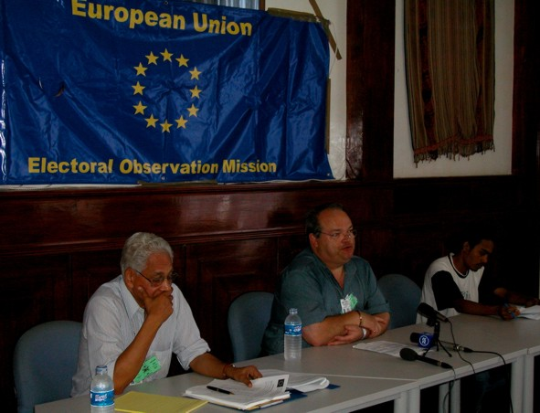

Press Conference on the 8th of April

“I am honoured to be here as the outward and visible sign of the European Union’s continuing support for East Timor, as it moves towards the new chapter in its history as an independent Nation.
“My first impression is of a beautiful land with a remarkable people, who have emerged from a long period of oppression, culminating in a tragic and traumatic outburst of violence and destruction. Yet they have come through those trials and torments with an enhanced determination to build a united, stable Country, where justice and democracy prevail.
“We have a common interest in seeing this determination carried through. The strongest plea put to me since my arrival has been: ‘Please, Europe, don’t abandon us now’. That is a strong message that I shall carry back to my colleagues in the Parliament, Commission and Member States of Europe.
“But let me say to the people of Timor Loro Sa’e: We stood with you in 1999. We have worked with you at every stage of the way since then, rebuilding the institutions of democracy. We are with you today and we shall be with you tomorrow – and all our tomorrows.
“Part of that continuity of support is my Mission’s role in observing this Presidential election. It is fundamentally important that East Timor demonstrates to the world that it is embarking on independence on sure and democratic foundations. Those foundations include a credible, fair and respected electoral system, freedom of speech, movement and assembly; freedom from fear, harassment and undue pressure; a free press, an independent judiciary and fair opportunities for political opposition.
“With my team of my Deputy Chief Observer, Antonio Menezes, our Timorese and international support group and our four long-term and 30 short-term observers, we are now all fully operational. We are observing, visiting, questioning, listening and looking in all parts of the Country. After the campaign and count, I shall be able to issue our initial conclusions, before leaving East Timor. A little later we shall publish more detailed conclusions on this election and its lessons for the future. I hope this will prove helpful both to the leaders and people of East Timor and to its future partners in Europe and the wider world.”

Press Release

Dili, 11 April 2002

Warning by EU Chief Observer, John Bowis, on Election Allegations
The European Union’s Chief Election Observer, John Bowis M.E.P., today issued a warning that the credibility of the Presidential election was being at risk by reports of elements that were encouraging voters to spoil their ballot papers.
“It is entirely up to each individual whether he or she votes and how he or she votes. I have no quarrel with anyone who decides intentionally to abstain. What is quite wrong is to fool people into thinking they can validly vote for both candidates. Such a vote would be invalid. It would not count; it would be entirely wasted. Equally wrong is to suggest the election is unimportant and that people should not take it seriously or vote at all.”
“This is the final vote before Independence can be declared. East Timor has struggled for the democratic right to self-determination. It has voted democratically and in large numbers for Independence; it has voted democratically and in large numbers for a Constituent Assembly; now it must vote democratically and in large numbers for a Head of State. My team of European Union Observers – the largest team and the only one covering every district of East Timor – has reported to me their concern about attempts to confuse voters into spoiling their votes.
“That would be harassment of and undue pressure on people and, if such a campaign were to be successful, I should find it very hard to give EU endorsement to the result. I hope very much that these fears will prove unfounded. The message must be: You have one vote; don’t let anyone persuade you to waste it; use it in support of whichever candidate you believe should be President of your Country, as it moves to Independence.”

Press Release

Dili, 14 April 2002, 19:00

EU Chief Observer says Polling Day Proceedings Impressive
European Union Chief Observer, John Bowis, M.E.P., tonight congratulated the election staff on conducting the polling day proceedings. “My initial response is that the polling day proceedings have been impressive. For the first time Timorese polling station staff have been in full control and they have carried out their responsibilities coolly and effectively.
“I also congratulate the voters on the dignified way they have gone to the polls. It was a slow start in many places but the additional number of polling stations and the decision of people not all to rush to vote at the opening of polls have meant no serious delays and an orderly process. I am still receiving reports from our team of 40 observers across the Nation but the feeling is: so far so good – a few minor problems around the Country did not have any significant impact on the overall good impression.
“Now we move on to the count. I shall announce our initial conclusions on the campaign and election process as a whole, immediately following the declaration of the result.”
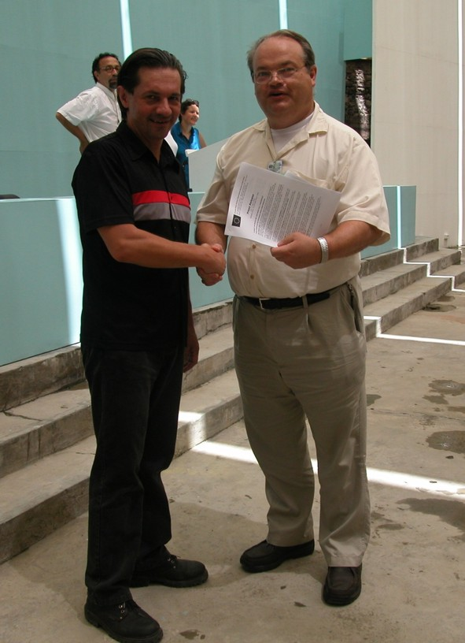

John Bowis, EU Chief Observer, hands Carlos Valenzuela, Chief Electoral Officer, the Initial Statement of the EUEOM

Press Release

Dili, 17 April 2002, Release time: 12:00 East Timor Time

A result in which we can have full confidence

Initial Statement by European Union Chief Observer
John Bowis MEP, the Chief Election Observer of the European Union Election Observation Mission today expresses the satisfaction of himself and his 40-strong observer team in the campaign, polling, counting and declaration of the result of the East Timor Presidential election. A final report will be produced shortly.
“First, of course, on behalf of the European Union, I give my warmest congratulations to East Timor’s new President on his election. Secondly I salute the East Timorese people for the way they conducted themselves before, during and after the election. I wish President and people well as they now move towards May 20th and Independence.
“I am very happy to confirm that our conclusion is that the way the campaign has been run and the way election officials carried out their duties, both on Polling Day and at the Count, means we can have full confidence in the result.
“Overall the picture on Polling Day was one of confident competence among the polling station staff in most areas and this continued through the transport of ballot boxes, their opening, reconciliation and counting.
“The training for this was effective and it means there is a competent team of East Timorese to run elections in the future, even if they may need to seek continuing advice and support from international experts.
“Turnout, at 86.2%, was very high and the low number of abstentions, blank ballot papers and voting for both candidates shows the voters were not misled and that they understood the importance both of voting and of voting for one candidate only.
“The campaign between the two candidates was courteous and without personal abuse. I pay tribute to the losing candidate, whose conduct throughout contributed to the dignity of the campaign. Where there were more aggressive statements, these came from other individuals, not in the entourage of either candidate, and such interventions proved ineffectual.
“Party agents and national observers were evident at polling stations and counts. They seemed generally alert and well informed as to the procedures. A meeting of 13 local observer groups confirmed their view that the election was satisfactory.
“Some concerns we have that need to be addressed for the future are:
- It is important that elections continue to be supervised by an independent electoral body, comparable to the IEC. It is also important that the experience gained by Timorese election personnel is retained and developed.
- The right to vote at this election without a register of voters was acceptable in the special circumstances of this Presidential election. It enabled anyone to vote anywhere, which was helpful for returning refugees and for those affected by the rainy season. It is unfortunate that the UN could not rectify in time the civil register, which had been found to be inaccurate at the time of the assembly election. In future there should be an accurate electoral register for each polling centre area.
- Evidence of having voted was the inked finger and the sticker on the proof of registration card or paper. Neither is satisfactory for the future nor a sufficient safeguard against double voting. The inked finger is visible and could be a deterrent to voting if there is ever intimidation of people to persuade them to vote or not to vote. The sticker was supposed not to be removable, but, where people had laminated their card for protection, the sticker could be removed without leaving a mark.
- Proof of Identity was based on the photograph on the proof of registration card. If a genuine ID card is to be part of the system in the future, photographs need to be of better quality.
- National observers should be encouraged to organise themselves into coordinating networks, to ensure greater influence and an adequate spread of monitoring throughout the Country. Individuals need to be registered and accredited, as well as their organisation, to ensure there is public confidence in their impartiality.
- Although there were more polling centres this time, many voters still had to travel considerable distances, often on foot. A further decentralisation of polling centres should be considered.
- The length of time between the close of poll and the declaration of result is not desirable. Counting could take place at the polling centre, under the supervision of the Presiding Officers. If it is still considered preferable to count at District level, additional trained counters would speed up the counting process. People in occupations such as teaching could be considered.
Finally I would congratulate the United Nations Transitional Authority for their work to ensure the smooth running of the election and, in particular, the Independent Electoral Commission for their planning and training and overseeing of all the electoral arrangements. The real winners, however, in this election are the East Timorese people. To them I say: 'You have once again shown your determination to participate in the democratic process. You have done so with dignity and maturity. You can look forward with confidence to Independence. We in the European Union are ready to work in partnership with you in this new Chapter in the History of Timor Lorosa’e'.”

List of Media Interviews
Press conference at the start of mission 8/4/2002
Interviews Timorese Media
Radio UNTATAET and TVTL
Interviews with Radio Renascenca
Portuguese media: Radio TSE, RDP and Lusa News Agency
Briefings with the international media: AP, EFE, BBC World and free lancing Journalists

List of Contacts by the Core Team of the Mission
C. Stewart, Political Advisor to the SGSR
Sergio Vieira de Mello, SGSR
Xavier do Amaral
Xanana Gusmao
Commissioners of the IEC
Carlos Valenzuela, Chief Election Officer
Mario Carrascalao-PSD
Celestino Amaral
Milena Pires, Campaign Manager of Xanana Gusmao
Amb. Pedro Moutinho de Almeida – Head of Portuguese Mission
Head of UNDP
KOTA. Political Party
Partido Democratico
ASDT
Head of UK Mission
Head of Mission of Ireland
Head of Mission of Australia

In spite of repeated requests to and frequent promises from Fretilin that a meeting would be arranged with the EU Chief Election Officer this did not materialize till the end.

Official Election Result
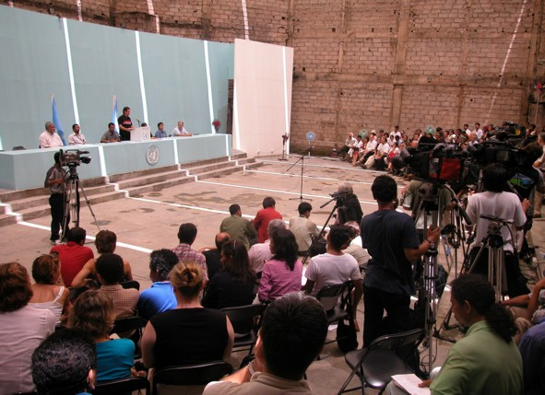

The Chief Electoral Officer declares the Final Election Result

Presidential Election
National Result
Candidate | Number of votes | Votes as a % of total valid votes cast
Xanana | 301634 | 82.69%
Francisco Xavier  do Amaral | 63146 | 17.31% | Votes as a % of total votes cast
Total valid votes | 364780 | 100.00% | 96.36%
Invalid votes | 13768 |  | 3.64%
Total votes | 378548 |  | 100.00%

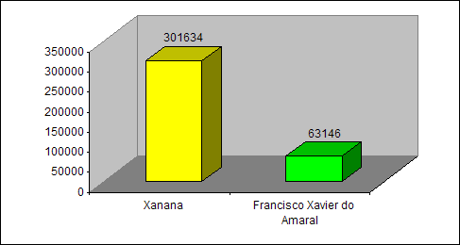

Source: The East Timor Independent Election Commission

