ASSOCIATION OF CENTRAL AND EASTERN EUROPEAN ELECTION OFFICIALS

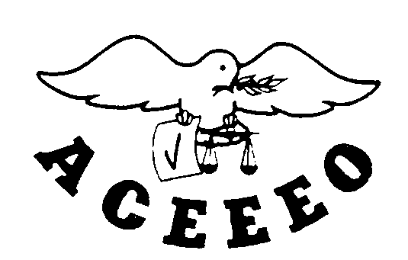
АССОЦИАЦИЯ ОРГАНИЗАТОРОВ ВЫБОРОВ СТРАН ЦЕНТРАЛЬНОЙ И ВОСТОЧНОЙ ЕВРОПЫ

RECOMMENDATION

ON MEDIA COVERAGE OF ELECTION

- The General Assembly of the Association of Central and Eastern European Election Officials (ACEEEO) calls its Member States to take appropriate measures to promote the national legislative background of media coverage of elections. For this reason the national legislation shall cover the basic international legal documents, such as Universal Declaration of Human Rights and the European Convention for Protection of Human Rights and Fundamental Freedoms, as well as generally applicable norms (lex generalis) and media-related specific norms (lex specialis).
- The Member States shall take into account when promoting the national legislation that the generally applicable norms shall cover:
- the citizens’ right to adequate and balanced information;
- equal treatment of political parties and candidates irrespective of their actual political power;
- safeguarding the public interest;
- minimum standards determining the rights of the political parties and candidates for free air-time, advertisements and campaign debates.

The special media-related norms shall cover:
- equal rights for media to access adequate and balanced information;
- minimum standards on equal treatment of media representation of political parties and candidates during the campaign;
- minimum common standards on the use of Internet by political parties and candidates during the entire period of the election;
- sanctions breaking the basic rights concerning freedom of expression and equal treatment.

- Member States shall take the necessary measures to develop, in close co- operation with the representatives of the media sector, a Code of Ethics for journalists.

