Rule 14 Principal Area Rules

The ballot papers
14.—(1) The ballot of every voter shall consist of a ballot paper and the persons remaining validly nominated for the electoral area after any withdrawals under these rules, and no others, shall be entitled to have their names inserted in the ballot paper.
(2) Every ballot paper shall be in the form of the Appendix, and shall be printed in accordance with the directions in that Appendix, and—
  - shall contain the names and other particulars of the candidates as shown in the statement of persons nominated;
  - shall be capable of being folded up;
  - shall have a number printed on the back;
  - shall have attached a counterfoil with the same number printed on it.
(2A) If a candidate who is the subject of a party's authorisation under rule 4A(1) so requests, the ballot paper shall contain, against the candidate's particulars, the party's registered emblem (or, as the case may be, one of the party's registered emblems).
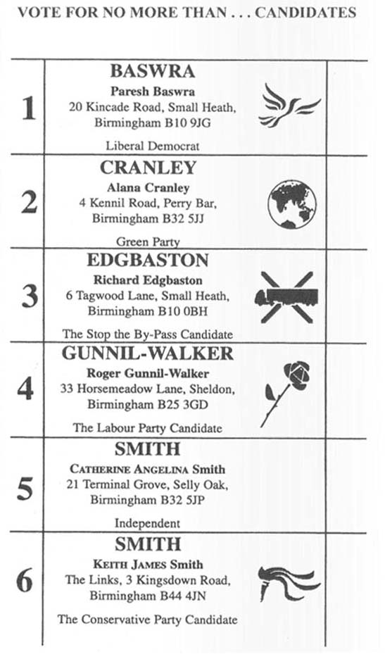
Form of back of ballot paper
No.
Election for the..........electoral division/ward of the [county/district/London borough/county borough of..........]
on..........19....
Note. - The number on the ballot paper is to correspond with that on the counterfoil. Rule 14(2)
Directions as to printing the ballot paper
1. Nothing is to be printed on the ballot paper except in accordance with these directions.
2. So far as practicable, the following arrangements shall be observed in the printing of the ballot paper:--
  - no word shall be printed on the face except the direction “VOTE FOR NO MORE THAN .......... CANDIDATES” or, where only one candidate is to be elected, “VOTE FOR ONE CANDIDATE ONLY” the particulars of the candidates and words forming part of emblems;
  - no rule shall be printed on the face except the horizontal rule separating the direction mentioned in paragraph (a) above from the particulars of the candidates and the horizontal rules separating the particulars of the candidates from one another and the vertical rules separating those particulars from the numbers on the left-hand side and the spaces on the right where the vote is to be marked;
  - the whole space between the top and the bottom of the paper shall be equally divided between the direction mentioned in paragraph (a) above and each of the candidates by the horizontal rules mentioned in paragraph (b) above.
3. The direction mentioned in paragraph (2)(a) above shall be printed in large capitals.
4. The surname of each candidate shall in all cases be printed by itself in large capitals, and his full particulars shall be set out below it and shall be printed in ordinary type except that small capitals shall be used--
  - if his surname is the same as another candidate's for his other names; and
  - if his other names are also the same as the other candidate's either for his home address or for his description unless each of them is the same as that of another candidate with the same surname and other names.
4A. Where an emblem is to be printed against a candidate's particulars--
  - it shall be printed between the candidate's particulars and the vertical rule separating the candidate's particulars from the spaces where the vote is to be marked, and
  - its size as printed shall not exceed two centimetres square.
5. The number on the back of the ballot paper shall be printed in small characters.

