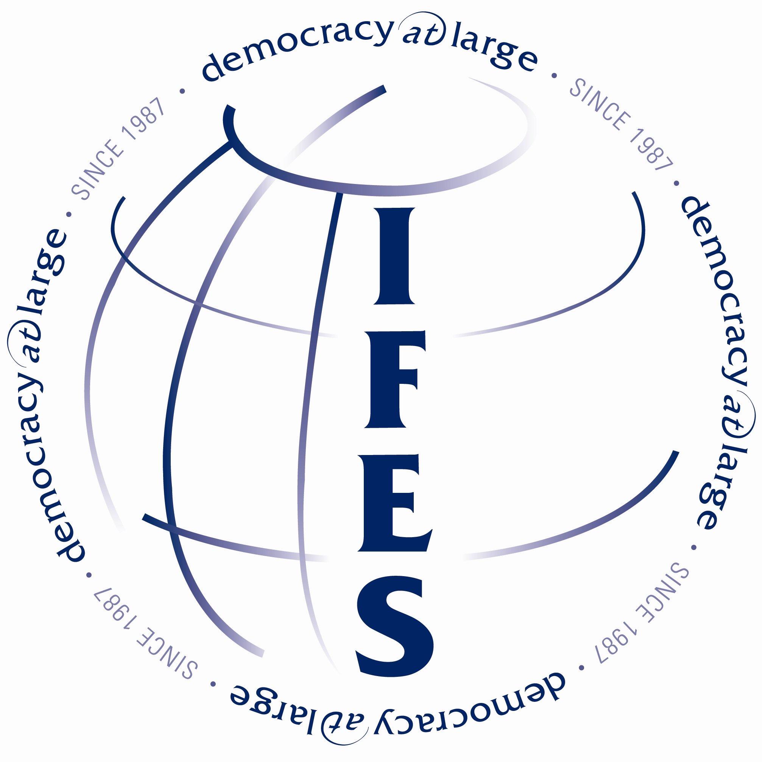

Job Requisition

Position: Field Coordinator Electoral Operations
Division: MENA
Location: Baghdad, Iraq

About IFES:
IFES is an international, nonprofit organization that supports the building
of democratic societies. IFES provides targeted technical assistance to strengthen transitional democracies. Founded in 1987 as a nonpartisan, nonprofit organization, IFES has developed and implemented comprehensive, collaborative democracy solutions in more than 120 countries.

Project Title: Electoral Technical Assistance to the Independent Electoral Commission of Iraq (1002-512)

Project Description: With support from USAID, IFES’ role in the continuing the electoral process in Iraq will be to provide institutional support and technical advice to the Independent Higher Electoral Commission of Iraq (IHEC) along with the United Nations (UN) Electoral Assistance Division. Activities under this program include: training of election administration staff, advising on the development of laws and procedures pertaining to elections, and education of voters and election stakeholders regarding the electoral process. Project duration contingent upon continued funding.

Responsibilities:
Under the direction of the Chief of Party:
- Advises and assists the IHEC develop programs to identify possible operational threats for future electoral events
- Advises IHEC and IEAT with current needs assessments leading to the resolution of possible operational threats regarding electoral activities (including voter registration and all other field based activities).
- Provides advice, assistance and coordination with regards to general operational planning within the IHEC.
- Works with IHEC Field Coordination and Support Unit and IEAT to develop a draft national plan.
- Keeps up-to-date the Governorate Electoral Office’s electoral preparedness records

Main IHEC counterpart:
Director of Operations

Qualifications:
- Minimum of five years experience with election administration and international program management;
- Proven track record with democracy and governance programming in developing countries;
- Preferred ability to formulate formal and informal training programs.
- Team player with excellent interpersonal/representational skills;
- Excellent oral and written communication skills.
- General project management skills, including project reporting.
- Experience working or living in a developing country preferred.
- Arabic language skills preferred.

Successful candidate will be able to demonstrate the following attributes:
- Team player
- Flexible
- Leader
- Mentor
- Creative
- Problem Solver

Applying:
Applications will be accepted online only, through the IFES website. To apply visit our careers website at http://www.ifes.org/careers.html. Then follow the instructions on how to upload your resume and answer prescreening questions. A cover letter is welcome and can be placed in the applicant notes section.

EEO/V/D/M/F
#55-07

